**FAMU-FSU College of Engineering   
Department of Electrical and Computer Engineering**

**EEL4914C/4915C – ECE Senior Design Project II**

**Detailed Design Review and Test Plan**

Design Team #: **ECE #3/ME #21**

Project title: **Formula Hybrid / Electric Vehicle**

Student team members:

- Aldreya Acosta, Industrial Engineering (Email: [aa09c@fsu.edu](mailto:aa09c@fsu.edu))

-Tomas Bacci, Mechanical Engineering (Email: [teb08@fsu.edu](mailto:teb08@fsu.edu))

- Danny Covyeau, Electrical Engineering (Email: [dc08k@fsu.edu](mailto:dc08k@fsu.edu))

-Scott Hill, Electrical Engineering (Email: [sbh09d@fsu.edu](mailto:sbh09d@fsu.edu))

-Stephen Kempinski, Mechanical Engineering (Email: [smk09f@fsu.edu](mailto:smk09f@fsu.edu))

- Ryan Luback, Industrial Engineering (Email: [rll07d@fsu.edu](mailto:rll07d@fsu.edu))

-George Nimick, Mechanical Engineering (Email: [gan07@fsu.edu](mailto:gan07@fsu.edu))

-Sam Risberg, Mechanical Engineering (Email: [sjr07c@fsu.edu](mailto:sjr07c@fsu.edu))

- Corey Souders, Industrial Engineering (Email: [cls07n@fsu.edu](mailto:cls07n@fsu.edu)

Senior Design Project Instructor:

**Dr. Michael Frank**

**Dr. Hui Li (Advisor)**

**Dr. Patrick Hollis (Advisor)**

Submitted in partial fulfillment of the requirements for

EEL4911C – ECE Senior Design Project I

February 2, 2012

# Executive Summary

This project's initiative is to design a Formula race vehicle using hybrid or electric technology. The sales group that this will be marketed for is the non-professional weekend autocross competitor. The design of this project will be centered on the intended sales group as well as focusing on the goal of making this easy to manufacture. The vehicle’s design and performance will be evaluated at an international competition hosted by the Society of Automotive Engineers (SAE). At this competition, there will be two main categories of judging that the vehicle will undergo, which are the static and dynamic events. The static portion of the event will involve the design review of the vehicle and the accuracy of the build compared to the design. This event will also review the safety of the vehicle, which is required before moving on to the dynamic portion of the competition. The dynamic event is subdivided into a three subcategories: acceleration, autocross and endurance. These subcategories are selected to test the individual systems of the vehicle to their extreme. The performance of the vehicle should reflect the performance of each system of the vehicle and the vehicles will be ranked accordingly. There are three major judging categories to compete in, which are Hybrid-In-Progress, Electric, and Hybrid. Hybrid in progress is basically an all electric category that is meant for first year teams that have the intention of doing a hybrid car in two years. There is also the actual hybrid category that includes vehicles that have implemented a combined system of an electric motor and an internal combustion engine. The electric category is new this year that involves vehicles that will only perform using an electric motor.

The vehicle being designed will be separated into two major systems: mechanical and electrical. All systems will be design using the constraints included in the rules document provided by the judges. The mechanical system will consist of four primary categories that will include, steering, suspension, braking, and chassis. The design approach will be discussed in more detail below, however the essential goal that is sought in all of them is effectiveness, lightweight, durability, functionality, and integration. For example, the chassis needs to provide a platform for all the systems to connect and at the same time provide a structure that houses and protects all of its components. Ideally, this should not be overdone and it should be optimized to reduce weight for the increase in performance. The electrical section is designed in a similar matter, in terms of optimization and inter-compatibility with the other systems.

The electrical section is subdivided into two primary categories, which are battery management and motor design. The motor controller, which controls the operations of the electric motor, must be able to handle varying inputs from the accelerator pedal and properly regulate energy from the batteries to propel the car. The electrical motor must be powerful enough for the car to complete the electric acceleration test. Efficiency and power output are of great importance for the electric motor. The accumulator must be compact, lightweight, and be able to robustly handle high g-forces and multiple high power discharges to successfully complete the competition.

# Table of Contents

Executive Summary ii

Table of Contents iii

1 Introduction 1

1.1 Acknowledgements 1

1.2 Problem Statement 1

1.3 Operating Environment 1

1.4 Intended Use(s) and Intended User(s) 1

1.5 Assumptions and Limitations 2

1.6 Expected End Product and Other Deliverables 2

2 System Design 3

2.1 Overview of the System 3

2.2 Major Components of the System 6

2.2.1 High Voltage Accumulator 6

2.2.2 Battery Management System 6

2.2.3 Charging Circuit 6

2.2.4 Ground Fault Detection 6

2.2.5 Low Voltage Accumulator 7

2.2.6 Motor 7

2.2.7 Controller 8

2.2.8 Chassis 8

2.2.9 Suspension 9

2.2.10 Braking System 10

2.2.10.1 Brake Calipers, Rotors and Pads 10

2.2.10.2 Brake Lines and Fluid 10

2.2.10.3 Brake Master Cylinder, Pedal, Brake Bias Adjuster 10

2.2.11 Steering 11

2.2.11.1 Rack and Pinion 11

2.2.11.2 Steering Joints and Wheel 12

2.3 Performance Assessment 12

2.3.1 Battery System and BMS 12

2.3.2 Motor and Controller 12

2.3.3 Chassis 13

2.3.4 Suspension 14

2.3.5 Braking System 14

2.3.6 Steering 14

2.4 Design Process 14

2.4.1 High Voltage Accumulator 14

2.4.2 Battery Management System 15

2.4.3 Motor and Controller 15

2.4.4 Chassis 16

2.4.5 Suspension 16

2.4.6 Braking 16

2.4.7 Steering 17

2.5 Overall Risk Assessment 17

3 Design of Major Components 18

3.1 Battery System 18

3.2 BMS Configuration 19

3.3 Ground Fault Detection 20

3.4 Charging System 21

3.5 Low Voltage Accumulator 22

3.6 Motor Controller 22

3.7 Optoisolator Circuit 22

3.8 Chassis 23

3.8.1 Ergonomics 25

3.9 Suspension 27

3.10 Braking 30

3.11 Steering 31

4 Test Plan 32

4.1 System and Integration Test Plan 32

4.2 Test Plan for Major Components 32

4.2.1 Battery System Testing 32

4.2.2 BMS Testing 33

4.2.3 Low Voltage Circuit Testing 33

4.2.4 Ground Fault Detection Testing 33

4.2.5 Potbox Testing 33

4.2.6 Throttle Isolation Circuit 33

4.2.7 Electric Motor Controller Testing 34

4.2.8 Chassis 34

4.2.9 Suspension 35

4.2.10 Braking 35

4.2.10.1 Calipers 35

4.2.10.2 Pads and Rotors 35

4.2.10.3 Brake Lines 36

4.2.11 Steering 36

4.2.11.1 Free Play in the Wheel 36

4.2.11.2 Quick Disconnect 36

4.2.11.3 Reverse Ackermann Geometry 36

4.2.11.4 Non-Binding 36

4.3 Summary of Test Plan Status 37

5 Schedule 40

6 Budget Estimate 41

6.1 Budget 41

6.2 Purchase History 41

6.3 Present Purchases 41

6.3.1 Electrical 41

6.3.2 Mechanical 41

6.3.3 Industrial 42

7 Conclusion 43

8 References 44

9 Test Plan Documents 45

Appendices (optional) 60

Appendix A – Chassis 60

Appendix B – Braking 63

Appendix C – Steering 64

Appendix D - Electrical System Figures 65

# Introduction

## Acknowledgements

The SAE Formula Electric Team would like to extend their gratitude for the monetary contributions made by Cummins, Inc., the FAMU-FSU College of Engineering Dean’s Office, along with the contributions made by the College’s Mechanical Engineering, Industrial Engineering and the Electrical Engineering Departments. Their monetary contributions, as of this moment, are the sole source of funding for this project. The team would also like to acknowledge the assistance and guidance provided by the College’s faculty, especially Dr. Patrick Hollis and Dr. Hui Li, as well as the College’s chapter of the Society of Automotive Engineers for their contribution of resources and advice, notably Anthony Sabido. The team would also like to thank Nathan Scott for his help on the design of the electrical portion of the project

## Problem Statement

A student conceived, single driver, formula all electric racecar is to be designed and fabricated with the intent of competing with it in the 2012 Formula Hybrid competition. One of the design’s most difficult challenges will be to make sure it abides by all competition rules. These rules place many restrictions on areas like the chassis design, braking system, and accumulator size that must be carefully considered. The vehicle will be designed as a prototype of a compact, agile car that should appeal to the average non-professional weekend autocross competitor. Since it is competing under the all-electric category the vehicle will use batteries as its sole energy source, since there will be no internal combustion engine (ICE). The car must be safe to operate and be equipped with multiple safety and emergency features.

## Operating Environment

The operating environment that the team will design for will be a smooth racing track, with banked turns and sharp turns, such as the New Hampshire Motor Speedway where the competition will take place. The vehicle will be driven and tested out in parking lots prior to competition for tuning purposes, but the main goal will be for it to complete the acceleration and endurance events at competition grounds. The vehicle needs to be water-resistant enough to operate during rainy conditions as well. Safety is a major concern since the vehicle will be competing in a racing environment where a crash is always possible.

## Intended Use(s) and Intended User(s)

The vehicle is meant to be designed for the non-professional weekend autocross competitor. However, the main intended users for our specific prototype will be our team members as well as any competition representatives. The vehicle must be designed to accommodate drivers from the 95th percentile of men (max) to the 5th percentile of women (min). For team members to be able to race at competition they will need to provide a valid driver’s license, provide proof of insurance, and be capable of handling and controlling the vehicle at high speeds. Additionally anyone driving the car will be wearing protective equipment (suit, helmet, gloves).The vehicle will be used to compete at the 2012 Formula Hybrid competition under the all-electric category.

## Assumptions and Limitations

**Assumptions:** The following assumptions were made by the design team in regard to the project. The vehicle is being designed to compete in a closed track environment; therefore it will be optimized for smooth, solid surfaces as opposed to hilly or off-road conditions. The team will have some vehicle parts and materials donated to them, and they will function correctly. The car is being designed for daytime use as the group will not focus on components such as lights or reflective panels for night time visibility. The team, or some portion of the team, will travel to Loudon, New Hampshire for the competition event in late April.

**Limitations:** The major limitations of this project are embedded in the 2012 competition rules. One of these is a limit on the accumulator system of 5,400 Wh or max price of $7,200. The vehicle must complete a 75 meter stretch in less than 10 seconds as a minimum completion requirement. The roll hoops on the chassis must be made from one continuous tube (no welds). The car needs to be able to seat a person from the 95th percentile of men to the 5th percentile of women. The braking system must apply force and be able lock up every wheel, successfully stopping the vehicle. The suspension system must keep the vehicle with at least an inch of clearance with the road, and must provide the wheels with at least 2 inches of wheel travel. With the exception of minor tuning and aesthetic features, the project must be completed by mid April as the competition begins on April 30th 2012. The project must be funded and completed with the allotted budget.

## Expected End Product and Other Deliverables

The end product will be an all electric, compact, single driver vehicle that is agile and fun to drive. The vehicle will be energy efficient and be able to participate competitively in local race tracks. The batteries will be included with the vehicle and will be capable of being recharged on board the vehicle from any standard household outlet.

# System Design

## Overview of the System

The design being proposed is that for a competition being hosted by the Society of Automotive Engineers under the Formula Hybrid Student Design Competition. It was agreed upon by the team to design for the fully electric category and, thus, the component break down will reflect this decision. Although the vehicle will be fully electric, there will be several mechanical components, as well as electrical ones. Mechanical systems on this vehicle will include systems such as braking, suspension, chassis, steering and power train. The electrical systems will include an electric motor, the controller and its subcomponents, as well as a battery management system.

This design is a vision of the end product that this team feels is tangible in terms of design and feasibility, using our proposed budget. However, this will be contingent upon the amount of funds that are allotted to us. An increased budget would have changed the vehicle by monetarily permitting a two motors and better vehicle components, whereas our current monetary allotment would only permit us to use one motor and the same components used in previous years.

The budget is only one of many constraints placed on the vehicle. The majority of the constraints will be a result of the rules we must follow in order to participate in the competition. Although these rules lead many of the design systems in a particular direction, there is still enough freedom to develop unique and effective designs. One of the goals, however, is to improve upon the design from the past two years. This may involve optimizing the existing design or a complete redesign. Below are the two top level designs that illustrate the required components to make the vehicle function, as currently envisioned by our group of two electrical engineering students and four mechanical engineering students. Figure 1 is the top level design for the mechanical aspect.

The electrical system of the formula hybrid car is laid out as seen in the top level electrical diagram in Figure 2. This system consists of a high voltage battery pack that sends current to the motor controller which uses high power MOSFETs to properly control the motor. The low voltage battery pack is used for all of the circuitry that enters the cabin area and is used for powering things like the contactors. All low voltage systems that communicate with high voltage systems are isolated as required by the 2012 Formula SAE Hybrid rules.

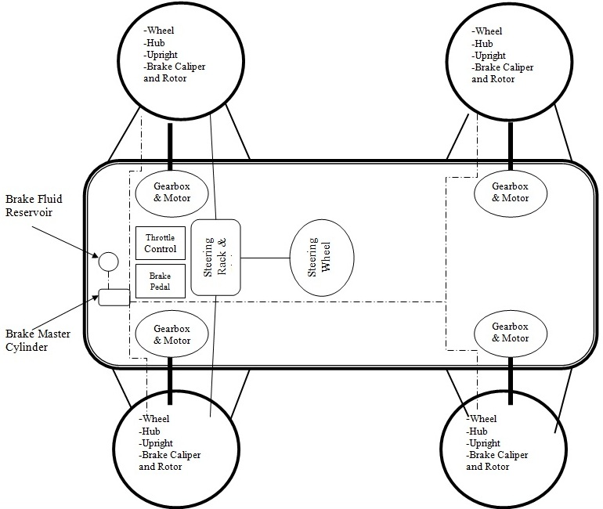

Figure : Mechanical Top Level Design



Figure : Electrical Top Level Design

## Major Components of the System

### High Voltage Accumulator

The high voltage accumulator will be the main means of powering the electric motor of the vehicle. It is being designed at 72V and 30Ah of capacity. The original type of battery that the vehicle was designed for was the Turnigy 3.7V 5Ah Lithium polymer battery. The team encountered some issues in obtaining these batteries caused by unavailability of using a purchase order to buy the batteries. By the time the team was ready to order the batteries, they were on a backorder status with an unknown amount of time until the batteries would even be in stock. Due to the tight timeframe that the team is on now at this current point in time alternative types of battery chemistry are being re-evaluated with more weight put on the time to obtain them. These types of batteries are discussed in chapter 3 of this paper.

### Battery Management System

Since lithium polymer batteries are extremely volatile the BMS of the vehicle is a very important component of the system. If the batteries are overcharged or over-discharged or the temperature is allowed to get to hot then the batteries can explode in a ball of fire. The BMS takes constant readings of the voltage and temperature of the batteries and turns off charging to a part of the battery circuit if it determines that the voltage is nearing upper or lower bounds and it also checks the temperature to make sure the battery is not getting too hot. One of the advantages of the lead-acid batteries being looked at is that they do not require a BMS, thus reducing the complexity of the system.

### Charging Circuit

The charging circuit for the vehicle allows for the team to recharge the batteries once they have been used for a distance. Calculations for charging time are included in chapter 3. One thing to take into account with other types of batteries, other than Li-Po batteries, is the ease of charging.

### Ground Fault Detection

The ground fault detection circuit of the vehicle ensures that the high voltage circuit will not energize the frame of the vehicle. If the frame of the vehicle was energized, then the driver of the vehicle or anyone in contact with it could be in extreme danger and could even be killed. The ground fault detection circuit is wired in series with the large red buttons on the vehicle and creates an open circuit if a certain voltage is read between the frame of the vehicle and the high voltage accumulator.

### Low Voltage Accumulator

The low voltage accumulator will be used to power all of the components of the vehicle that are not used to propel the vehicle. This includes but is not limited to: Electrical control unit (ECU), fault detection circuit, BMS master board, rpm sensors and may other items. Since this accumulator is a low voltage of only 12V it will be grounded to the frame of the vehicle.

### Motor

The Motor is an Agni 95R permanent brushed DC motor. The motor peaks at 93% efficiency. It can output approximately 22 kW continuously, as well as 42 Nm of torque (continuously). It also weighs a mere 24 pounds and is a popular option among other formula hybrid teams. Figure 3 is a graph from Agnimotors.com showing the performance curves of the motor at our intended voltage level.

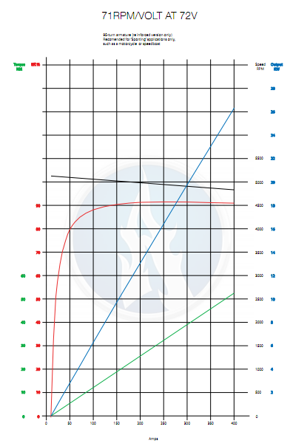

Figure 3: Performance Curve of the Agni Motor

### Controller

The controller to be used is the Kelly KD72501. This controller uses high power MOSFETs to achieve 99% efficiency in most cases according to Kelly Controls, LLC. The motor has a continuous current rating of 200 amps and can handle 500 amps for one minute which is perfect for allowing our car to let loose during long straight-aways.

The controller also has a built in regeneration feature that allows the motor to be used as a generator during braking, which allows the kinetic energy of the vehicle to be recaptured and stored back in the batteries. This feature is not a replacement for mechanical brakes due to competition rules. It is also not as effective as mechanical brakes as it can only recapture 100 amps peak. This gives a peak reward torque at the motor of 10.5 Nm which is not enough to quickly bring the vehicle to a standstill as desired in a performance vehicle. This feature is currently not being pursued as other features have higher priorities.

The controller is also programmable through Kelly’s free user-friendly GUI. Through this feature the peak current, minimum high voltage level and other parameters can be set to help protect the vehicles vital components.

### Chassis

The chassis that is being built is essentially one unified structure that serves several purposes. Although it is possible for the chassis to be comprised of several separate parts, our team has decided that the best and most effective chassis will consist of several frame members that are welded together. These individual frame members, along with the tabs and other mounting points are the major physical components of the chassis. The chassis as a whole is also segregated in the 2012 Formula Hybrid Rules document into sections regarding required characteristics. These sections are as follows: main roll hoop, front roll hoop, roll hoop bracing, roll hoop bracing supports, front bulkhead, side impact structure, and impact attenuator. Each is given specified characteristics and minimum specifications. All definitions are provided in the Rules document, but are also listed as follows and can be seen in Figure 4 below:

**Main Roll Hoop** – A roll bar located behind the driver’s torso.

**Front Roll Hoop** – A roll bar located above the driver’s legs.

**Roll Hoop Bracing** – Frame members that provide support for the main roll hoop and the front roll hoop

**Roll Hoop Bracing Supports** – The structure from the lower end of the roll hoop bracing connecting back to the respective roll hoop.

**Front Bulkhead** – A planar structure that defines the forward plane of the major structure of the frame and functions to provide protection for the driver’s feet.

**Side Impact Structure –** The area of the side of the car extending from the top of the floor to the 350mm or 13.8 inches above the ground and from the front hoop back to the main hoop

**Impact Attenuator –** A deformable, energy absorbing device located forward of the Front Bulkhead.

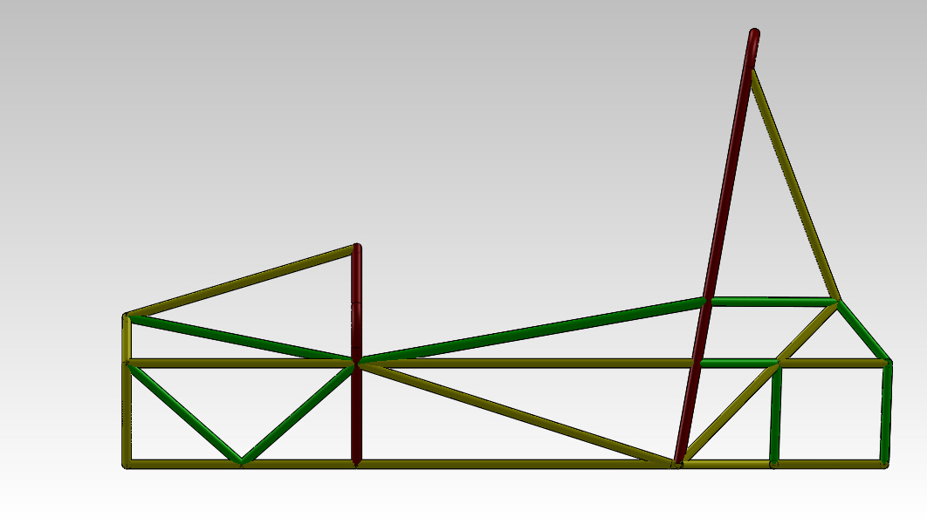

Main Roll Hoop

Front Roll Hoop Bracing

Front Bulkhead

Front Bulkhead

Bracing

Front Roll Hoop

Side Impact Members

Main Roll Hoop Bracing

Figure : 3-Dimensional Model of Current Chassis

### Suspension

The suspension system will connect the vehicle’s sprung and unsprung weight (wheels to chassis) and allow the driver to maintain traction and stability while cornering or accelerating. The suspension geometry uses a multi-link independent set up for each of the wheels on the vehicle. The suspension is being designed to provide maximum traction and stability by limiting toe in the wheels and providing negative camber gain with rising wheel travel. The front of the vehicle will use double wishbones with pull rods, and also have tie rods to connect the steering. The rear will use double wishbones, pushrods, and an extra toe control link since the rear wheels will not steer. In either case of the push or pull rod, the idea is to transfer the forces acting on a wheel to rise to a spring damper set up, allowing the wheel to maintain contact with the road and therefore better traction. Each wheel will have one degree of freedom in the vertical direction (jounce, rebound) by restricting the others with the five- link connection. The suspension will meet the requirements of the competition as it will have a wheelbase of 62 in, allow for 2 inches of travel (1 in jounce, 1 in rebound), and suspend the car over 1 in at all times.

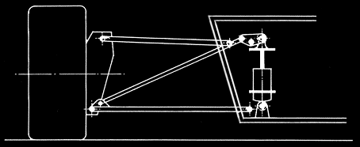

Figure : Push rod configuration example. A bell crank transfers tire forces traveling through the push rod to a spring dampener.

### Braking System

The braking system will use outboard brakes mounted to the hubs in the front. In the rear, there will be an inboard system to simplify the sprung weight. This means that there will be 3 brake lines going to two central master cylinders, which we will control the front and rear proportioning of the brake pressure. One master cylinder will control the front brakes with a t-fitting and a line for each the left and right calipers. There will also be a master cylinder dedicated to the rear caliper.

#### Brake Calipers, Rotors and Pads

The most fundamental part of the braking system is the calipers, rotors and pads. Once the pressure is sent though the lines, the calipers will compress pads. Eventually the pads contact the rotors and slow its rotation, which is rigidly connected to the wheel. The rotor is made of metal, but the pads are semi-metallic or possibly ceramic which is a softer metal then the steel rotor, so the pads will slow the rotor down with pressure and friction.

#### Brake Lines and Fluid

Before the brake pad compresses on the rotor, the brake lines have to send pressure to the caliper. Once the fluid forces pressure to the caliper, the piston inside the caliper is forced away from the center and pushes out into the rotor with the pad between the piston and rotor.

#### Brake Master Cylinder, Pedal, Brake Bias Adjuster

Even before the brake lines send pressure to the caliper, the brake master cylinder must be compressed. This is accomplished by pushing a pedal that has a pivot point and allows for much more force to be exerted at the master cylinder. When the cylinder is compressed, the fluid can then compress the caliper. We have decided to use a brake bias adjuster seen in Figure 6, which will allow an adjustment in brake pressure for the front and rear. This will allow us to change the proportioning of the brake pressure and allow the front or rear to receive more or less pressure individually. The plan is to make this process remote.

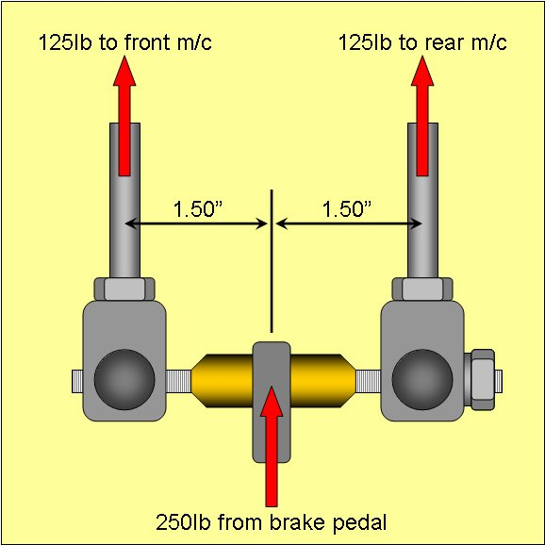

Figure : Example of a Brake Bias Bar

### Steering

The steering system is responsible for taking the rotational input of a steering wheel and using it to accurately control the motion of a vehicle. In most cases, this transfer of motion is easily attainable with proper hardware and gears.

#### Rack and Pinion

Changing the motion of front wheels without power steering in production cars can be tough due to the engine’s weight in the front of the car. Our designed vehicle does not have this issue as the majority of the weight is in the rear and, therefore, lighter in the front. As a result, a simple rack and pinion with reverse Ackermann geometry has been selected to steer the front wheels. At approximately 600 lb, the car does not weigh enough to need power steering, so a dry rack and pinion will be used to turn the front wheels.

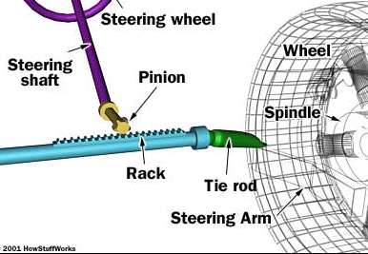

Figure : Rack and pinion concept illustrated. Rotational motion of pinion displaces rack horizontally, turning the wheels.

#### Steering Joints and Wheel

The steering joints used will be rod ends that attach the tie rods, a U-joint to transfer the rotation of the wheel to the pinion gear, and a column bearing to fix the steering column. The wheel will have a quick disconnect hex, as required by competition rules.

## Performance Assessment

### Battery System and BMS

The battery system that the vehicle was designed for was a lithium polymer (Li-Po) system with a Battery Management System (BMS). The light weight property of each battery (114g) and the high discharge rate of 20C are two of the biggest advantages of this system with Li-Po batteries. The Li-Po batteries, if used, would fulfill the requirements of a BMS for the vehicle by monitoring the voltage and temperature of each parallel string of batteries. If a battery type, such as lead acid, is used then a BMS will not be required and a deep cycle charger can be used to charge the batteries in a much safer fashion then the Li-Po batteries.

### Motor and Controller

The motor puts out 42 Nm of torque consistently from about 0 to 50 mph. Assuming a gear reduction of 4.5:1, this results in 189 Nm of torque at the rear wheel through our differential.

Table 1 depicts common coefficients of friction between a tire and asphalt. The coefficient of friction of 0.9 represents a tire similar to a racing slick that has a lot of grip. The coefficients of friction of 0.5 and 0.8 represent coefficients that can be expected from a typical street tire. 0.1 represents a tire in contact with a wet road. We want these torque ratings to meet or exceed the peak torque at the rear wheels so that the wheels do not spin under hard acceleration. As can be seen from the table, as long as the track is dry the motor should perform well.

Table : Torque and Coefficients of Friction

|  |  |  |  |
| --- | --- | --- | --- |
| CF | Mass Over Rear Axle (assuming 50:50 weight distribution) | Wheel Radius, r | Peak torque before tire slips  τ = M*g*r*CF |
| 0.9 | 150 kg | 0.254 m | 336 Nm |
| 0.8 | 150 kg | 0.254 m | 299 Nm |
| 0.5 | 150 kg | 0.254 m | 187 Nm |
| 0.1 | 150 kg | 0.254 m | 37 Nm |

Due to a 4.5:1 gear ratio the top speed of the car cannot exceed 79.3 mph. This is due to the motor having a top speed of 6000 rpm at 72 volts. This speed is perfectly acceptable for the car as the top speed to be competitive in the endurance event of the competition is only 65.2 mph.

This motor is also capable of accelerating the car a distance of 75 meters from a standstill in less than 10 seconds as the competition rules require. Assuming 189 Nm of torque, this equates to an acceleration of 2.48 m/s2. According to the formula,

$75 m=\frac{1}{2}*at^{2}$ (1)

the time to complete the acceleration run is 7.8 seconds. This is the approximate time that the 2010 FAMU-FSU Formula Hybrid team completed the acceleration event in with the same motor. Therefore, we feel that this calculation along with the information above show that this motor is a suitable choice for our vehicle.

Depending on the high voltage accumulator’s size, which is only limited by the budget right now, the vehicle should have an excellent shot at completing the endurance event (22 km). The 2010 team completed the endurance event with the same motor, a heavier vehicle and a battery pack that had a max capacity of approximately 2220 Wh.

### Chassis

The chassis’ performance will be assessed in a few different manners, which will involve its comparison to the Rules document, comparison to the spatial and mounting requirements of various components, as well as some consideration for the ergonomics of the chassis in relation to the driver.

The first and foremost methods of assessment will be designated through the use of the Rules document to ensure that the chassis meets the required specifications to pass the technical inspection. This, however, will be a continuous process until the actual design is practically finalized and the Rules will then govern any final changes made to the chassis. In a practical sense, the fitment of components in regards to room and mounting will be assessed through 3-Dimensional modeling and ultimately assessed after the vehicle is built, with hopefully nothing more than minor changes needed. Essentially, the spatial requirements will govern a large portion of the design and the assessment of that portion of the design will be determined through the actual fitment.

### Suspension

The suspension will need to meet the requirements of the competition that include having a wheelbase of over 60 inches, allow for 2 inches of travel (1 in jounce, 1 in rebound), and suspend the car over 1 inches at all times. The geometry decided upon will undergo simulations using ADAMS modeling software to ensure desired specifications are met. The wheelbase will be set by the attachment points from the control arms to the chassis. The wheelbase of the vehicle will be verified to conform to the rules as well as suspension travel. The control arms will be verified to allow for at least 2 inches of travel using ADAMS software, and will be verified by hand after attaching it to the chassis, prior to loading the springs.

### Braking System

To examine the braking performance, we will have multiple physical tests. The first will be the visual test. When the brake is pressed, the calipers compress the pads on the rotor. This can easily be seen and, if not, the car will raised and to attempt to rotate the wheels while the pedal is engaged. The second test would be the physical braking test. Starting at low speeds we will test the functionality of the brakes. Eventually we will move to high speed braking to see the limitations of the tires and locking characteristics.

### Steering

To test steering performance, we can measure the angle difference in the front tires while the car is stationary. The steering wheel will be turned lock-to-lock, meaning all the way to the left and right until it hits the steering stops. This is to ensure that there is no binding within the links, but also to verify that no part of the wheel assembly contacts suspension or chassis members as they are turned. Once the system is mechanically ready to operate on a working vehicle, it will be tested through several turns on a mock course to ensure it can properly guide the vehicle.

## Design Process

### High Voltage Accumulator

The high voltage accumulator was designed using a series of equations. These equations where used to create a model in MATLAB/Simulink in order to solve them while allowing for different variables to be changed during the design process. Two of the biggest factors that affected the design of the high voltage accumulator were two of the events at the formula hybrid competition. The first event is the acceleration event where the team must accelerate a distance of 75m in under 10 seconds. The second event that affected the design of the high voltage accumulator is the endurance event. From research we have found that in past competitions the teams that finished the endurance competition generally ended up in the top 10. This is because the endurance competition is worth so many of the points at the competition. The original battery type that was going to be used in the vehicle was the lithium polymer battery. The team ran into many problems ordering these batteries and then by the time the team had put in the order for the batteries they were on backorder for an indefinite amount of time. The shortage of time the team has been put on in order to finish the project in time has made the team decide to go with lead acid batteries. This is because they are more readily available and are available at a lower cost.

### Battery Management System

The battery management system (BMS) of the vehicle was designed around the lithium polymer batteries that had been originally selected. The configuration of the BMS was chosen to be 20 cell boards connected in one bank. This is because the team was going to use parallel packs of 6 batteries repeated 20 times in series. The cell boards can be connected to an unlimited number of batteries in parallel. The only other option the team could have gone with for the lithium polymer batteries would have required 120 cell boards. This is because the other option for wiring the batteries would have been 20 batteries in series repeated 6 times in parallel. These cell boards would have measured the cell voltage and the cell temperature and relayed this information to the BMS master that would control the charging and discharging of the circuit. Due to the issues with getting the lithium polymer batteries and the team’s decision to go with the lead acid batteries the use of a BMS will not be required. This is because lead acid batteries are a much more stable chemistry that will not combust to the extreme that lithium polymer batteries will if they are discharged or charged too much.

### Motor and Controller

The biggest decisions that have been made this far affecting the electrical system have been due to the limited amount of funding that the team has received this year. In order to pursue a lithium polymer battery system and a new BMS system, the car’s design has been re-evaluated several times to reduce costs. The car originally was a 4-motor design that placed one motor at each wheel. Each motor would then have an identical gear reduction to a drive shaft connected to the wheel. This was quickly determined to be too expensive and too complex to complete in a year so a two-motor approach was decided upon to reduce cost. These two motors would be run in series on a single controller, creating a differential effect on the rear wheels. After some time this was also determined to be an unreachable goal. The team has, therefore, chosen to go with a one motor, one controller design to save money. The motor and controller from the previous years’ team will be reused to give other team members more money for the areas of the vehicle that they’re focusing on. The motor and controller have been thoroughly reviewed to make sure they are still suitable for this year’s car.

### Chassis

The chassis is designed using the same guidelines through which it will be assessed; therefore, the design assessment ought to go fairly smoothly. The design begins by taking into consideration the major components of the vehicle in regards to how and where these will be fitted or mounted, with a general idea of the rules kept in mind. This allows for the preliminary shape of the vehicle to take place. The Rules document then takes a more significant role as certain aspects are governed by them, primarily for safety reasons, such as material properties, heights of bars and mounting requirements. These are simultaneously considered throughout the entire design phase so that extra work is avoided from having to continuously redesign to satisfy all aspects. Once it appears that most aspects have been satisfied, everything is reviewed thorough to make any necessary changes, which is then followed by a finite element analysis (FEA). This is used to determine better placement of members, the removal or addition of frame members or as a justification or criticism of the wall thicknesses chosen.

### Suspension

The suspension design process involved accommodating an existing, yet flexible, chassis with a suspension that would meet specifications set forth by competition rules while providing good handling and stability to the vehicle. The type of suspension was determined to be multilink independent for the front and rear. The vehicle wheelbase was selected at 62 inches, close to the minimum of 60 since we have a relatively short chassis. The track lengths were decided upon once a wheelbase was set. Drawings that accounted for the front, top, and side views of the suspension arms were made for both the front and rear axes in order to set the geometry of the control arms. This allowed for specific parameters to be designed for in multiple views. From the drawings, an ADAMS suspension was built on the computer for analysis.

### Braking

The initial design of the brake system will be simple with 3-Dimensional modeling and checking the see if there is proper clearance between all the parts. The only necessary parts that will have clearance issues are the caliper, the rotor and the pads. When the hub is designed the caliper will have to fit on so that there is no contact with the rotor at all. Also the caliper must not touch the rims of the car. Also, if the caliper is misaligned then the pads will wear unevenly and braking will be effected.

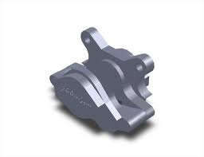

Figure : 3-Dimensional Model of a Brake Caliper

### Steering

The vehicle will be using an adaptation of the previous year’s design for its steering set up. This simplifies the task as some of the components have already been purchased, such as the rack and pinion. It allows the group to concentrate on performance, as it has already been verified that its functionality meets competition specs. The rack and pinion will attach to tie rods through rod ends. From a top view, as can be seen in Figure 9, the angle that the hub and rod ends make determine the Ackermann geometry when steered. Keeping this angle below 90 degrees will ensure that the vehicle exhibits reverse Ackerman turning. Rack and pinion steering was selected mainly because of its ease of installation, cheap cost to the project, and ability to meet the competition requirements.

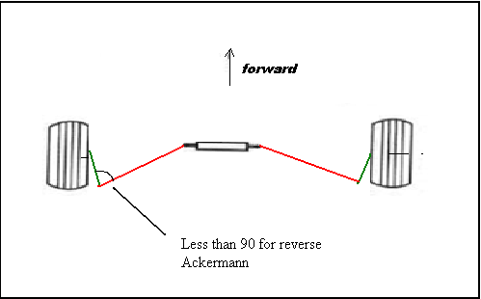

Figure : Basic Reverse Ackermann Steering Geometry

## Overall Risk Assessment

The quality and successful completion of this project requires that we forecast and manage any risks and complications that would stall the project’s forward movement.  As with any project involving new designs there are risks that plans made will not work and may need revision.  Recognizing this possibility in advance will allow us to be ready for it and take these problems in stride.  The following is a breakdown of foreseeable or possible complications.

Technical risks are design, integration and project completion risks that may impact the success of the project. In our design, these can come from systems not working as intended, or not working within the acceptable guidelines of the competition.  In some ways, a car made successfully for personal use may not meet requirements for competition use.  Acknowledging that we are constructing this vehicle to eventually compete in this competition successfully, we must constantly assess whether it is following competition requirements that assure it fulfills an acceptable design, maintains a high level of safety, and performs on par with other vehicles of its type.

Scheduling is very important for achieving many goals of the project and cannot be overlooked. If goals are not reached in the schedule time, negative consequences will arise and affect the project being completed on time. Different measures will be taken to make sure each step is achieved in the schedule time.

Budget risks are risks that may produce budget overruns.  These can include additional support costs, unexpected material or equipment costs, component or system failures, underestimation of costs. Keeping updated records of spending and the amount left in the budget will help avoid some of these risks. Proper planning will also provide significant help with the budget.

# Design of Major Components

## Battery System

The requirements for the specifications for the battery system for the vehicle were determined by creating a mathematical model in Matlab/Simulink. A picture of the model is shown in in Figure B. The model in Figure B shows that at the desired system voltage of 72V and a capacity of 30Ah is desired in order to complete the endurance event at competition. With the current state of events, completion of the acceleration event with an alternative type of battery will be very difficult.

The reason for this is because with the desired Li-Po batteries a discharge rate of 20C is easily obtained without the assistance of other accumulators, such as ultra-capacitors. With batteries such as lead acid or NiCd, a much lower discharge rate is normally obtained. A vehicle using lead acid batteries could definitely compete in the acceleration event, so long as things like ultra-capacitors are implemented. This is out of the reach of this year’s team, but the team that takes over the project next year could try and implement such items. This would also allow the possibility of regenerative breaking as well.

With Li-Po batteries, the battery system would look like the schematic shown in under Figure A. This system consists of 20 parallel strings of 6 cells with a total of 120 batteries. With Lead acid batteries that is a multitude of battery sizes that could be easily connected in 6 batteries in either 1 parallel string if a capacity of around 30Ah is available or 2 parallel strings if the capacity is around 15Ah.

One of the glaring advantages of using the lead acid batteries at this point in the project is the speed at which it can be obtained once ordered. The Li-Po batteries are usually shipped from places like China where the shipping time can easily exceed 3 weeks. The lead acid batteries could be shipped in a matter of weeks and would be purchased form a local seller of the batteries vs. an international website as with the Li-Po batteries

## BMS Configuration

The two BMS’s that have been sourced for the vehicle are the Elithion BMS and the Orion BMS. There are pros and cons of both systems. The team can already make use of an Elithion BMS from the previous year’s vehicle. If the Elithion system was used then all that would need to be purchased is the cell boards for the vehicle. These cell boards are priced at around $10 each and different configurations of these boards will be discussed later in this section. The team has decided to go with the Elithion BMS since it is already in the team’s possession and it can be implemented into the project.

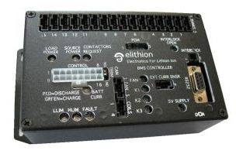

Figure : Elithion BMS Master Board

As stated previously, the batteries will consist of 6 Li-Po batteries in parallel repeated 20 times in series. The reason for this is because the Elithion cell boards can handle an unlimited number of batteries in series and only 1 cell is required for every parallel string. Therefore, this design will only require 20 cell boards. If our design had 20 batteries in series repeated 6 times in parallel then we would need a whole 120 cell boards to measure each individual voltage. This difference is about 100 cell boards and at $10 a piece this design saves the project about $1000.

To recapitulate the subject of the BMS, a basic explanation of how a BMS works is given below. The BMS measures the voltage across each cell and can stop the charging of the batteries if the individual cell voltage gets too far off from the rest of the batteries. The reason this needs to be done is because there can be devastating consequences if Li-Po batteries are in either under-voltage or over-voltage conditions. These consequences can include combustion of the batteries and cause a total system failure.

If batteries, such as lead acid, are used, the team will not need to use a BMS. In hindsight, the team should have made sure that the actual batteries had been ordered before the purchase of the BMS, but due to purchase order issues the BMS was ordered before the batteries were. The bright side of this though is that because the team chose to go with the Elithion system, a BMS master was not purchased, thus preventing the team from spending $1,000 more than needed.

## Ground Fault Detection

The ground fault detection device that will be used in the vehicle is the A-ISOMETER IR155-2 made by BENDER group. This device is being provided to the team free of charge where the team only has to pay $25 shipping and handling in order to receive the item.

This fault detection device is made for unearthed DC systems and is rated from 0V all the way up to 800V. The A-ISOMETER measures the insulation resistance between the high voltage bus and the frame of the vehicle to make sure that a fault has not occurred. If a fault does occur then a signal is sent to the ground fault detection switch and the system is shut down.

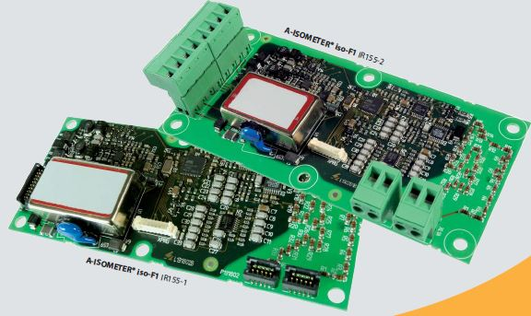

Figure : A- ISOMETER IR155-2 Fault Detector

Below in the wiring diagram from the spec sheet provided by BENDER is shown:

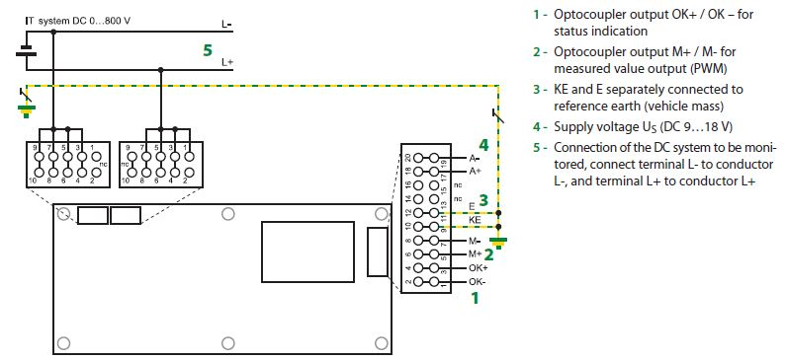

Figure : Wiring Diagram provided by BENDER

## Charging System

In the previous proposal, the battery system was being designed with a 144V accumulator in mind. Since the team has decided to go with a lower voltage 72V accumulator, a new charging system will be needed. Since the car will only have one battery pack, the vehicle will only need 1 charger. The charger that the team has chosen for the vehicle is the HWC4 Series charger with an output of 72V/30A and has a 220VAC input. This design also reduces the cost of the charger by around $200.

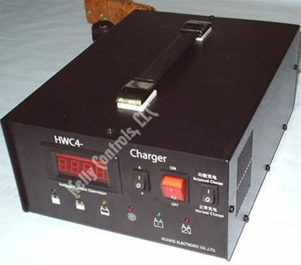

Figure :Battery Charger by Kelly Controls, LLC

Since the team will most likely be going with a lead acid battery configuration, simple deep cycle battery chargers can be used. One of the better possibilities for charging with this method would be to put relays in between each of the batteries and allow each battery to charge individually.

## Low Voltage Accumulator

The low voltage accumulator on the vehicle will consist of a single 12V lead acid battery. It will be used to power all of the sensors that are not attached to the high voltage circuit. The low voltage accumulator will also be grounded to the frame of the vehicle.

## Motor Controller

The motor controller is a Kelly KD72501. Figure 14 is a modified schematic from Kelly Controls, LLC that reflects the setup that will be used with the Agni motor. Please keep in mind that while the schematic does not display it, the switch and both potboxes will be optically isolated.

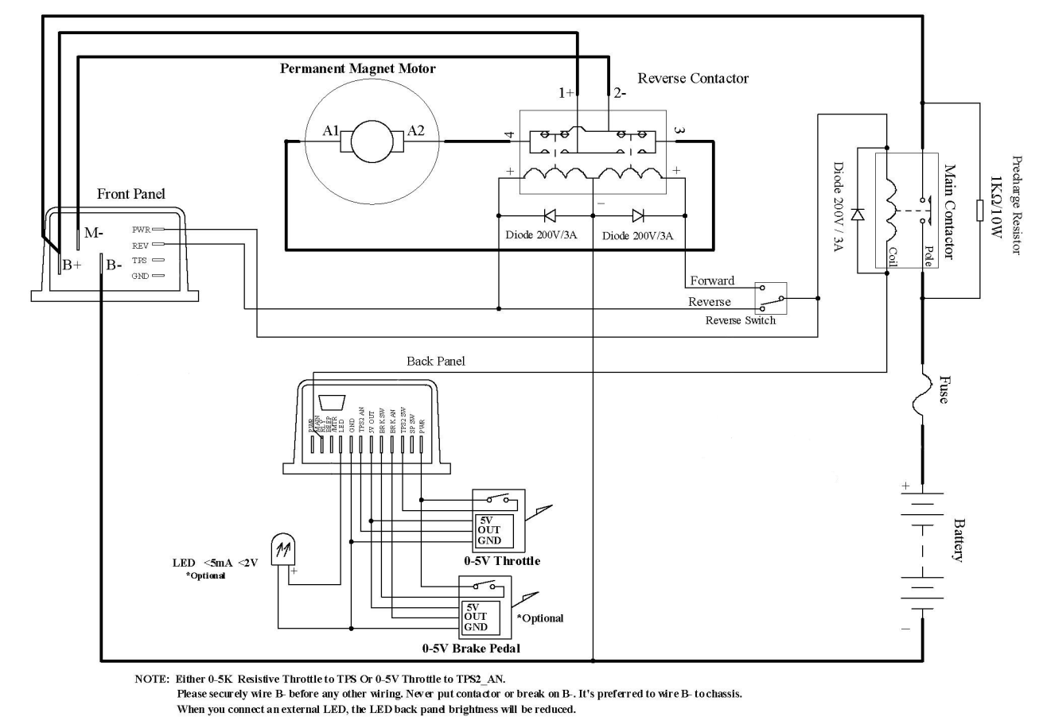

Figure : User Manual Courtesy of Kelly KD

## Optoisolator Circuit

Figure 15 is a schematic of the optoisolator circuit used throughout the vehicles electrical system. This allows low voltage analog signals to be communicated with high voltage components. This particular circuit in Figure 15 is the one used for the throttle potbox. The red wire is the +5V line and the black wire is the relative ground to the red wire. The white wire is the variable voltage line. The circuit is based on the 4N25 optocoupler IC. This circuit is used for the throttle potbox as well any other components that are within the cockpit that communicate with high voltage circuitry. It should be noted that this circuit is not used for the signals that power the contactors as the contactors are a type of relay which does not require optical isolation.



Figure : Diagram of Vehicle's Optoisolator Circuit

## Chassis

As mentioned previously, when considering the design of a system, component, or virtually anything, the goal of the design needs to be considered first and foremost rather than just using previous techniques solely because they are proven reliable. This exact perspective was used when designing the frame and several methods were considered, primarily dealing with the different materials that could be used for the construction. These materials, in some cases, make the nature of the design and build process inherently different.

The material consideration was initially divided into two categories: all metal or a composite chassis. The advantage to building the body from a composite material is that the chassis could potentially be very light and that the composite material would combine several duties that are usually handled by several components. It would not only replace the steel’s structural responsibility, but in addition, it would also serve as the floor pan and serve the duties of the body in terms of aerodynamics, aesthetics, and to protect the driver from debris. This structure is given the name of monocoque because it is all unified in to one piece, or at least the main cockpit area is. In order to do this out of composite materials, it would have to be done out of carbon fiber as a result of the strength requirement. The most appealing was the carbon fiber and aluminum honeycomb combination due to its strength to weight ratio, an example of which can be seen in Figure 16 below.

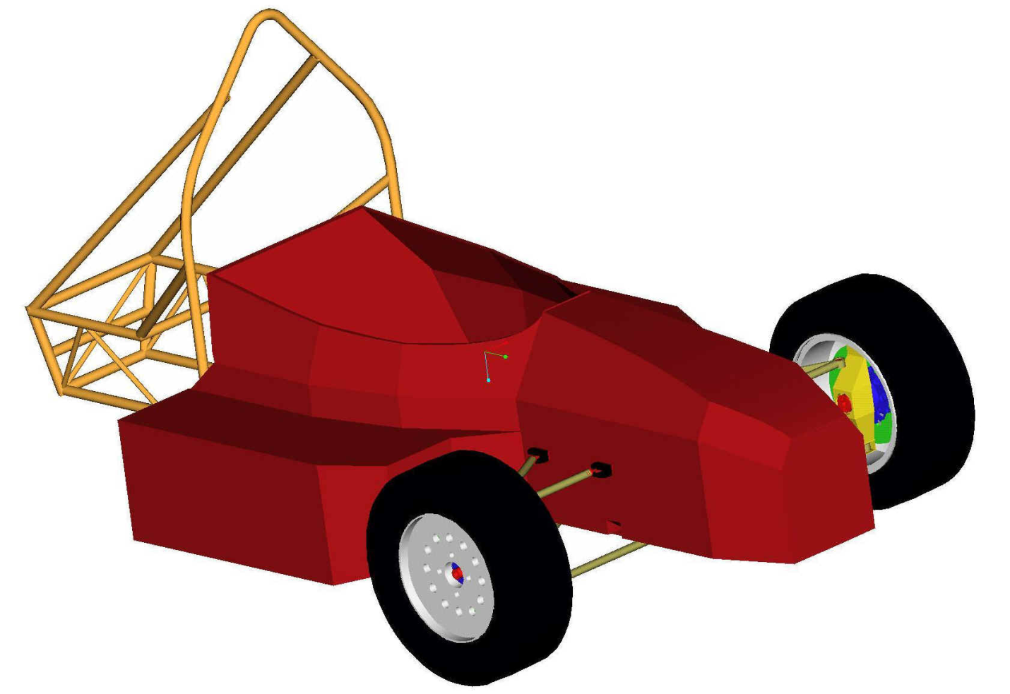

Figure : Composite Monocoque Chassis

It would be very difficult for this to be made and expensive for it to be bought. Therefore, the consideration of just carbon fiber was taken into account and it was primarily decided that, as a result of inexperience with this material, that we could consider an all metal chassis. The motivating factors for this decision were governed by lack of experience constructing something of this nature, lack of knowledge regarding the strength of the material and the amount of time that this process would take. Since the strength of the chassis is of great importance, primarily for safety reasons, it could not be guaranteed that, given the timeline, something suitable would be constructed with time left to perform testing.

The elimination of composite materials narrowed the options to an all metal chassis. According to the rules, certain items MUST be made of steel and, therefore, joining these two materials would involve a more in-depth view and be more time consuming and given the short timeline and very limited number of team members, it was then decided to remain with all steel. This, of course then narrowed the selection process down to the type of steel. Research was done to examine the type of steel that other teams used and why, and it was determined the 4130 chrome-moly steel alloy was the best because the weight increase of this alloy is so small that it is negligible and the strength gain is quite significant with its yield strength being nearly double of that of 1018 steel, which is the type of steel used as the minimum standard in the Rules document. The advantage of having a stronger material allows for the weight of the vehicle to potentially decrease because an equivalent or greater strength can be achieved be increasing the diameter of the tubing, which increases the moment of area and permits the wall thickness to decrease, allowing for less material. The only limitations are the minimum wall thicknesses prescribed in the rules. These calculations can be seen in .

One of the main guiding factors to the design of the chassis is the fitment of components and the serviceability of the end product with respect to the components that it will house. The purpose of the chassis is to provide a structurally sound enclosure for the driver and the components used to operate the vehicle, as well as to provide mounting points for any external components; therefore, the main design goal is to ensure that the structure can fit the required components and, without being able to physically test this, representative solid models must be created to test fitment to save time and cost during the actual building process. This can be a very time consuming process depending upon the level of detail included in the solid models. Although a great level of detail is not necessary, it can be advantageous to use when conducting a presentation in order to better describe a system or components. Realistically, the only detail required is the general shape and volume that the object will occupy and the mounting requirements for the part.

The chassis then needs to be thoroughly overviewed to compare against the requirements instated by the rules documents to correct any discrepancies. The chassis is continuously checked against the rules during the design process, but is most thoroughly reviewed once the chassis is close to being finalized. This prevents any issues during the build and will ease the preparation for passing technical inspection. Additionally, a finite element analysis will be performed. This will analysis will assist in dictating where areas will need to be strengthened, or, possibly, even where frame members can be removed.

The last overview of the chassis design will be an analysis of the feasibility of the build. This is something that is kept in mind throughout the design process, but is analyzed more thoroughly at this stage. This, essentially, is an examination of the chassis in regards to whether or not it can be built using the tools available and the difficultly that this will impose on the builders to construct it as shown in the 3-Dimensional model as accurately as possible.

The current status of the chassis design is that it has completed the 3-Dimensional model phase and is currently being fabricated. Prior to this, the chassis was reviewed and modified several times. Images were also sent to the mechanical scrutineers for review and were deemed to be approved for passing technical inspection, in regard to meeting the rules through proper triangulation. Proper heights and measurements were not verified because the actual vehicle may or may not be built or may not behave as modeled. Also, many parts were solid modeled and placed into a virtual assembly of the vehicle to determine position, mounting points, and adequate spacing.

### Ergonomics

When considering the ergonomics of the vehicle design, anthropometry had to be considered. Anthropometry is the application of scientific measurement methods to the human body in order to optimize the interface between humans and equipment. In this specific case only the measurements of team members who will be driving the vehicle during the competition have been considered since no one else will use it. Measurements of leg length, arms reach, and sitting height of drivers were factored in the design and these dimensions were established as the most significant. This was to ensure that each member would be able to operate the vehicle effectively while still maintaining comfort and safety through a long, grueling competition.

**Leg Lengths**

Members were measured from their hip to the floor to determine their leg lengths and that data was used to determine how far away the pedals would be. An additional 2 inched were added to the leg lengths in order to account for the driver pressing down on the pedal which would extend his foot. The placement had a significance importance because without proper placement a short driver might not be able to reach and tall driver could be too cramped with his legs affecting his cockpit space. In order to avoid this, a middle range was produced allow each member to reach the pedals while not having their knees in their chest.

**Arm Lengths**

After considering how far each driver’s legs would reach, measurements of arm reach were calculated to make sure that the steering wheel would not be too close nor too far away from the driver. If the driver had to reach a long distance this could possibly affect how well he or she operates the vehicle. Leaning towards the wheel to compensate would make the driver very uncomfortable. Designing the steering wheel too close would also be a problem by not allowing enough room in the vehicle to operate properly. The optimal placement of the steering wheel was chosen in the design according these constraints.

**Seated Height and Body Width**

Additional measurements of body width and seated height of the drivers were taken to properly plan for the user. The seated height was measured to determine how high the head rest should be place and only the height of the tallest driver was needed because anyone smaller would fit in that range. Body widths were also taken to ensure enough room for the driver while seated, allowing them to operate the vehicle smoothly.

**Safety and Comfort**

According to the competition guidelines, a driver must be able to exit the side of the vehicle in no more than five seconds. When planning the design of the cockpit, this must be taken into consideration to ensure the safety of the driver. By building it spacious, the driver will be able to sit comfortably and be able to exit the vehicle safely. An arm rest will be added to help elevate possible strain on the body. Also, a comfortable seat will be installed to minimize back pain for drivers that could possibly be driving for an extended time.

**Measurements**

|  |  |  |  |
| --- | --- | --- | --- |
| **Arm Length Range:** | **Leg Length Range:** | **Max Seated Height:** | **Max Body Width:** |
| 28” – 30” | 35” – 40” | 36” | 19” |

**Notes:** Measurements were taken for only team members who would be driving in the competition. This was to ensure the optimal placement of the pedals and steering wheel so that the driver could operate the vehicle effectively and safely. Seated height was measured from bottom of chair to top of head and arm length was measured from shoulder to palm of hand with arms being straight out.

## Suspension

**Wheel Base and Track Width**

The minimum allotted wheel base for the competition is 60 inches. There is no set way to determine the actual needed wheelbase; it is set to the choice of the designing team. A shorter wheelbase, however, induces a greater lateral force on the rear wheels in a turn. As a result, an increased lateral acceleration during corner which will increase oversteer characteristics, causing sharper turns. To account for this, a proper wheel track selection is required. Choosing a fairly wide track width has many advantages. Increasing track width reduces load transfer on turn entry resulting in tire loads being more evenly distributed. In doing so, this also improves the lateral acceleration capabilities as well as improved acceleration on turn exit. When comparing our 62 inch wheelbase with the chosen 48/44 front to rear track width with previous racing teams of formula SAE that out performed in past autocross events, our ratio of wheelbase to track width is within the same ‘ideal’ range as well as within the competition rules.

**Front Suspension**

**FVSA**

The SLA front suspension consists of two control arms and a steering linkage to constrain the movement of the wheel. Designing the specific geometry of these components takes into account many parameters of wheel travel along with force transfers. While the static load case of the wheel characteristics may be functional for a straight line velocity, the real purpose of the suspension is to handle cornering forces. During cornering, the outer wheel experiences a greater lateral force due to changes in lateral acceleration as well as changes in left to right weight distribution from a neutral standpoint. The short upper control arm feature of this design minimizes camber changes due to this change in lateral weight distribution but does not reduce the body roll moment that the vehicle experiences. As a result, the lateral force difference between the left and right wheel still remains.

The first step is reducing body roll. With a roll instant center (RIC) location close to the ground, the non-rolling overturning moment is reduced. As the suspension deflects in the turn, the outer wheel travels upward and the inner wheel travels down. This affect, called jacking, relocates the rolling instant center below ground. With a low enough static RIC location, the change from above to below ground causes the vehicle chassis to deflect down in thus reducing the rolling moment at the center of gravity.

With the difference of lateral forces between the inner and outer forces still remaining, it is critical to choose the most appropriate spring rates available. With the right spring rates between the driven and undriven axles, a balance between the two can increase traction and grip. With the rear driven axle, an increase of the spring rate on the front with a preloaded installed length, will balance the front and rear of the axle.

From the front view, the upper and lower control arms reach a point called the instant center. This length from the instant center to the center of the contact patch is called the front view swing arm (FVSA). The intersection of the instant center to the centerline of the contact patch from both sides will overlap at some point. This point is the determined location of the rolling instant center as seen in Figure 17. Thus, when designing the location of mounting points on the chassis and wheel hub, the desired RIC location needs to be considered. Another aspect that goes into the control arm geometry is the camber change rate. With a short FVSA length, the camber changes are larger than desired. To achieve small camber gains and losses, the FVSA length should be as long as possible while also achieving the desired RIC. Once the optimal FVSA length is found, another aspect to camber is to set the static camber angle slightly negative, about one to two degrees. With minimal camber change, this angle will always be negative which is desired to improve handling.

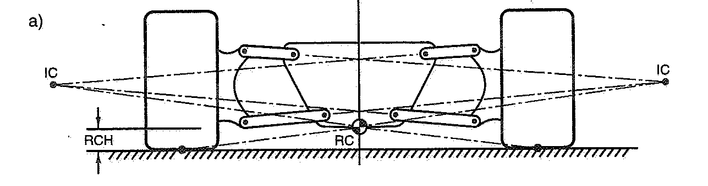

Figure : Roll Center Construction

The last feature of the FVSA is the scrub. The scrub is the resulting lateral motion relative to the ground during vertical wheel travel. To minimize the effect of scrub, the instant center of the front view is located on the ground. This is another parameter to consider when the final geometry of the front control arms is designed. By locating the instant center at the ground plane or just above it, see Figure 18, minimum scrub will be achieved while maintaining the previously discussed geometry requirements.



Figure : Scrub as a Function of IC Height

**SVSA**

The side view swing arm (SVSA) contributes to the anti-features of the vehicle. With longitudinal forces and motions in the fore and aft direction, these features will control dive, lift, squat, and wheel path. From calculations of desired features, the slope of the control arms is then determined. For a rear wheel drive vehicle, anti-dive prevents weight transfer to the front during braking application, controlling the pitch of the vehicle. Although front weight transfer is desired, weight still needs to be sufficient in the rear to maintain traction in the rear. With the addition of anti-dive in the front suspension, it may change the mechanical trail and or caster angle with bump travel, which is undesirable. So, the optimum SVSA for the front is placed at a relatively large length compared to the track width, which correlates to nearly horizontal control arm mounting points and minimal anti features in the front design, leaving these effects to be also accomplished in the rear suspension.

Mechanical trail, as defined in the below, creates a moment acting on the kingpin axis. This moment produces a self centering effect on the kingpin axis at speed. For manual steering, the mechanical trail/caster angle should be reduced to almost zero. The result in keeping this value at or close to zero prevents forward or backward movement of the tire.



Figure : Front Suspension Packaging

**Rear suspension**

**FVSA**

The SLA rear suspension consists of two control arms and a toe link to constrain the movement of the wheel. Similar to the front suspension, the design of the specific geometry takes into account many parameters of wheel travel along with force transfers. Starting with the roll instant center location, for rear wheel drive applications, the best acceleration out of a turn is achieved with a lower rear roll instant center than the front’s RIC. With the front design resulting in a RIC at or just above the ground plane, the only options is to have the front and rear RIC even or place the rear instant center below the ground. The effect of locating the RIC below ground is the downward movement of the rear chassis. This in turn increases the traction of the rear tires. The difference in lateral forces between inner and outer wheels still remains at this point. To keep traction on the inside wheel, the correct amount of spring stiffness and installed length needs to be addressed in order to achieve minimal body roll and weight transfer.

Similar to the front, the FVSA length should be adequately long to reduce the camber change rate. With the same methods used on the front, the rear control arm geometry can be determined by locating the instant centers and RIC. Furthermore, slight negative camber angles in the rear are ideal; approximately a half to one and a half degrees is desirable for optimum handling.

**SVSA**

The rear suspension will help control the pitch of the vehicle. Calculated anti-lift and anti-squat will control the vehicle as the weight is transferred front to rear. During braking, the anti-lift in the rear will limit weight transfer to the front tire. At the same rate, under heavy acceleration, the anti-squat will reduce the weight transfer to the rear.

**Overview of progress**

Understanding all of the features to account for when designing a suspension system is relatively complex. The suspension for this vehicle is making progress with final ideal location selections of wheel base, track width, rolling instant centers, instant centers and scrub, along with ideal handling camber angles for the front complete with the rear close behind. The next step will be to implement the rear specs into Adams-CAR. From this point we can test out our calculations and make single modifications to see what positive changes we can achieve. When the final simulations are completed, the Suspension will be finalized to fit the chassis, along with attachment brackets to be made. Slight modifications to the chassis have already taken place in order to accommodate the best suspension design as well as allow the chassis construction to begin.

## Braking

The design of the brake assembly will be left to Sam Risberg. There will measurements of the brake lines to ensure there is enough length to compensate for the new chassis. The calipers will need to be 3-Dimensionally modeled to the hub and make sure there are no clearance issues with any sprung masses or un-sprung rotational masses. The rotor should fit in either case and will require mounting to a hub with a proper bearing that will allow for smooth operation. The hub will be designed to compensate for the caliper, but, if there are any discrepancies, brackets can be made to allow fitment.

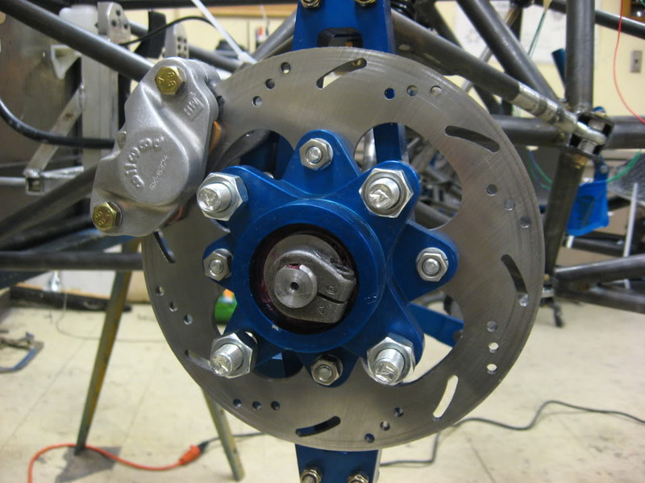

Figure : Example Brake Assembly

## Steering

Steering will be simplified to the easiest version of understanding by using rack and pinion steering. The rack being used is a 14" Mini Dune Buggy rack and pinion steering unit, obtained from last year’s formula team. It has a 12:1 steering ratio with a 1.5 inch lock to lock distance in the rack. Calculations in Appendix C – Steering show this allows for over 22 degrees of rotation at each wheel, which is more than adequate for our application. Due to high lateral accelerations in competition, tires will operate mainly on their slip angles, as opposed to the angles forced by steering assembly. It is important then to try to match the steering to these slip angles. The team, therefore, decided to implement reverse Ackermann as a steering geometry. Reverse Ackermann allows the outside wheel to turn sharper than the inside wheel, and it is also a fact that more weight is transferred to the outside wheel during a turn. Since tire performance curves (Appendix C – Steering) show that less slip angle at lighter loads reach the peak of cornering force curves, a small amount of reverse Ackermann will maximize performance while cornering. This is because the steering geometry will ease the alignment of the tires closer to their slip angles. Additionally, the rack will be mounted out of the way and below the driver’s feet, as can be seen on Figure 21. This means the rack will have to be angled so that the motion of the wheel can be transferred into the rack by the use of a U-joint. In order to achieve this, the team will bolt the rack to a plate, and weld the plate to a round chassis member at an appropriate angle so that the U-joint won’t bind when the steering column is turned.

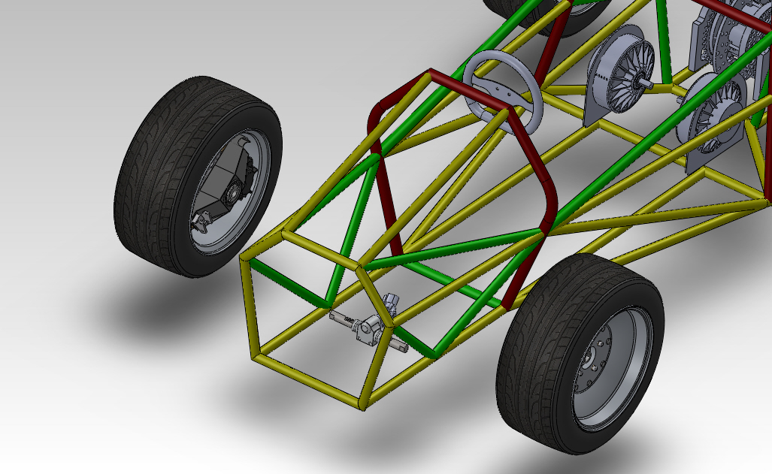

Figure : Steering Rack Location. Actual steering rack be will tilted.

# Test Plan

## System and Integration Test Plan

The integration of the systems below should be nearly seamless, provided that everything, indeed, has been given adequate room and is capable of mounting as planned. The reason that the separate systems should integrate well is that there is not necessarily a complex larger web of interacting systems. Rather, most of the systems on this vehicle will interact primarily through the chassis. Therefore, proper design of the chassis will be key when integrating, as it serves as the foundation and platform to which everything is mounted and how all the systems interact. The solid model of major components and fitment was the preliminary test for fitment. Ultimately, it will be the compilation of the actual assembly and testing the systems while mounted to the chassis that will determine the interoperability of the systems and their proper integration.

## Test Plan for Major Components

### Battery System Testing

The testing of the battery system will vary depending on the battery chemistry used. Since it looks like the type of battery that will be used is lead acid, aspects such as discharge rate and total charge time will be tested. The testing of the battery system’s characteristics will be followed with testing the integration of the battery system with the motor controller and motor.

### BMS Testing

The testing of the BMS will also depend on the battery type used. If the team is able to find a good source of Li-Po batteries in the immediate future that would allow for the team to get the batteries in time, then the BMS will be tested to make sure that it is indeed balancing the voltages of the batteries and making sure that the temperatures of the batteries is not exceeding its limits. The most likely battery type that the team will be using at this point though are the lead acid batteries, which do not require a BMS in order to make sure that he voltages of the batteries are staying constant. This is mostly due to characteristics, such as the discharge curves of the lead acid batteries vs. the Li-Po batteries.

### Low Voltage Circuit Testing

The testing of the low voltage circuit will start by testing the individual components in order to make sure that they are working. This will consist of testing items such as the energized strobe light that goes on top of the vehicle and the gauges that will be used in the vehicle.

### Ground Fault Detection Testing

The ground fault detection test will be carried out in the same manner as the test that will be carried out by the formula hybrid competition.

### Potbox Testing

The objective of this test is to verify the proper operation of the throttle potentiometer (potbox). The throttle will be tested to make sure that when hooked up to a five volt power supply that it delivers a range of voltage output between zero and five volts. This test requires a low voltage power supply, the potbox, and a voltmeter. The potbox is expected to act as a simple voltage divider and deliver voltage levels that range from zero to five volts. The potbox must deliver a range of voltages between zero and five volts to be considered functional.

### Throttle Isolation Circuit

This test is to ensure that the throttle isolation circuit works correctly (i.e. that the LV and HV grounds have a minimum resistance of 40,000 ohms between them and that the output voltage of the circuit corresponds linearly with the input voltage of the circuit). In order to test this, the optoisolator circuit will be built. A five volt source will be placed across the potbox (or a five thousand ohm potentiometer in the case that the throttle is not available). The potentiometer will be actuated randomly and the resulting input and output voltages will be measured with a voltmeter. The input is the voltage from the potentiometers wiper to ground. The input and output voltage of the throttle should vary from zero to five volts linearly.

### Electric Motor Controller Testing

The objective of this test is to verify that the electric motor controller works properly. This will be done by verifying that the forward and reverse functions of the motor operate. This test requires a power supply (preferably 72 volts), the Kelly Motor Controller (KD72501), the electric motor (Agni 95R), and all of the peripheral electronics connected to the controller. The motor controller should be able to accelerate the electric motor in both the forward and reverse directions. If the controller is capable of this, then the controller will be considered operational.

### Chassis

Due to a limited amount of time, resources and budget, a physical test of the limits of the chassis is unreasonable and inefficient. As a result, the tests performed on the chassis will be computer modeled and simulated and can technically be considered as part of the design phase. There will be three major tests that will be performed: fitment, finite element analysis, and a rules test.

The first test of fitment was heavily considered throughout the design and was performed by solid modeling parts that would be used on the vehicle and placing these parts into an assembly within the chassis model. This allows to design for and check for proper clearances between components members of the chassis or even other components. Critical components that influenced this test significantly were items such as the differential, the motor, the seat, a model person, the brake cluster, the rack and pinion, control arms and push/pull rods.

The second test is a more passive test. It is comprised of taking a compilation of the rules and verifying that the chassis conforms to them. Although this seems menial, this is a critical test because otherwise the vehicle cannot compete. This will ensure that there is proper triangulation between the members and proper clearances in relation to the driver. Most of these restrictions are placed for the safety of the operator and bystanders/volunteers that will be present at the competition.

The final test comprises of conducting a finite element analysis of the chassis. This is also a very critical test because, even though the chassis may pass the previous two tests, it is possible that, due to material constraints, the chassis may need additional frame members to assist in distributing the loads and stresses in the members to prevent deformation and failure of the tubing. This is very crucial since one of the primary purposes of the frame is protect the drivers and components that it houses. Doing this stress analysis will help determine its integrity and also in addition to determining the proper placement of members, it can be used to analyze the use of different outer diameters and wall thicknesses.

### Suspension

The test plan for the suspension consists of a two part phase. Phase one will focus on measurement and accuracy. Once all of the suspension components are completely fabricated, placements for attachment brackets connecting the unsprung mass to the sprung mass will be carefully marked on the chassis based on the designed measurements. Once all the mounting locations are determined, measurements to ensure they are symmetric on the chassis along the longitudinal centerline will ensure proper alignment can be achieved later on. The next element of phase one is to spot weld the attachment brackets to the chassis and preassemble the suspension arms and hubs. This step will ensure there is no binding, supporting our simulated results. With all the measurements verified once again, the attachment brackets can now be completely welded and the rolling chassis can be assembled.

Phase two of the test plan will be completed once the vehicle is able to be driven. Upon every test run, the suspension undergoes an analysis that will tell which adjustments to make until the car performs flawlessly. With various toe, camber, and caster angles along with tire pressure and dampening ratio changes that can be made, the car will be driven enough to fine tune the suspension as well as perform all the other tests simultaneously.

### Braking

The braking system will have a rigorous testing process considering the safety involved in designing this system. The braking system will need to not only stop the vehicle, but will need to make sure that the car will stop from up to 80 miles per hour and will lock up all four wheels. We will individually test every caliper, pads, lines and rotors for proper function.

#### Calipers

The calipers will be the component that houses the brake pads and will compress them on the rotor, which will slow/stop the car. The way to test this component is to make sure the cylinder in the caliper is working properly and will compress safely. Pulling each caliper off and placing it on a stationary rotor while holding the brake will prove holding power. Also, to check for leaks we will use visual confirmations.

#### Pads and Rotors

The pads and rotors are what the caliper uses to connect to the car and subsequently slow the car. To test these, we will check the material surface for grooves in the rotor or pads. After multiple high speed stops we will use a digital temperature sensor and make sure there are no hot spots on the rotors. Also if there are any grooved sections we will need to resurface the brake rotor to compensate. Grooves on the rotor prove there is imperfection in the pad causing the metal to “groove” the radius of the rotor. This can also mean the pad is producing pressure unevenly.

#### Brake Lines

Brake lines have one purpose, to keep the hydraulic fluid confined. To test this we will pump the brake system and check for leaks.

### Steering

#### Free Play in the Wheel

The competition requires that the steering wheel have no more than 7 degrees of free play. The actual rack and pinion in the car is being re-used, and it met this requirement two years ago at competition. However it is important for the team to verify this functionality. When assembled, the free play in the wheel will be verified by lightly turning the wheel and recording the angle until it causes wheel movement. It should be less than 7 degrees.

#### Quick Disconnect

The vehicle must have a removable steering wheel, as required by competition rules. With the driver in a seated position, a test of the driver egress sequence will be performed, as it is a competition requirement. During this test, the driver has to remove the steering wheel in order to exit the vehicle and therefore the quick disconnect feature will be verified to work at this time.

#### Reverse Ackermann Geometry

The actual steering response from the system will be measured for each wheel and compared to the other to determine the steering geometry. Due to our set up displaying only a slight amount of reverse Ackermann, the wheels should look as though they are turning closely parallel to one another. If for any reason the measured results on the assembly are not satisfactory, the tie rods must be adjusted until the correct geometry is achieved.

#### Non-Binding

The steering assembly will be turned from lock to lock distance in order to ensure smooth operation and that the hubs and wheels do not come in contact with suspension or chassis members. The travel of the steering tie rods must also show they don’t contact members during suspension travel (jounce and rebound).

## Summary of Test Plan Status

Testing has recently begun, but systems have not been fully tested. Some tests will need to be post-production, while others are ongoing now. Below is a sample chart that will be completed as tests are being completed. This will facilitate the documentation of whether a system still needs testing, if it needs some adjustment, or if the systems has successfully passed.

|  |  |  |  |  |
| --- | --- | --- | --- | --- |
| Test Performed | Tester’s Name | Date Performed | Outcome (pass/fail) | Comments |
|  |  |  |  |  |
|  |  |  |  |  |
|  |  |  |  |  |
|  |  |  |  |  |
|  |  |  |  |  |
|  |  |  |  |  |
|  |  |  |  |  |
|  |  |  |  |  |

Below is a sample of documentation of the status of a portion of the current testing that pertains to the vehicle’s design and how it compares to the rules set forth by the competition/

**Inspection of Design**

In our current inspection of the vehicle, we made many key discoveries that better equip us moving into construction. The inspection itself was a comprehensive look at every critical component of the vehicle design. In this sweep we found anything that might have fallen through the cracks or been put off until later. The Industrial Engineering students on the team are now also tasked with following up on anything that has not yet satisfied technical requirements and assuring that those items that are on track continue through to the completed vehicle.

Our inspection plan will consist of two more phases. We will inspect the vehicle concurrently with its construction to ensure systems are implemented in the necessary manner, and we will perform another comprehensive inspection of the vehicle at its completion to deem if it is competition worthy and safe for general usage.

As for the current inspection, most of our findings could be organized into the following categories:

* Components that need to be ordered
* Flexible systems that need to be designed around other finalized (built) components
* Inflexible systems that need to be designed further or redesigned

**Components that need to be ordered**

The following is a list of items that we had not realized for purchasing. Most are safety equipment requirements and competition necessities. Some we can procure for free from the competition and others are small items we could purchase at a hardware store.

|  |
| --- |
| Need to order |
| High Voltage (HV) Insulation (more) |
| HV box and stickers |
| HV and LV wiring (different colors) |
| HV Test Connector |
| Conduit anchors |
| Low Voltage Fusing |
| Electrical Relays (if we can’t find) |
| Fire Extinguisher |
| Rolling Bar Padding |
| Harness Replacement |
| Master Switches “Big Red Buttons” (more) |
| Lap Belt Mounting (or make) |
| Driver’s Suit (Gloves/Shoes/Face Shield/Helmet) |

Ordering these components is currently our top priority. Parts that are ordered that have not been received will be continuously monitored to ensure their swift arrival.

**Flexible systems that need to be designed around other finalized (built) components**

While these systems have been planned somewhat, a complete design of their position and integration into the built vehicle is not yet available and may require the prior completion of another component. These are generally lower in priority. Below they are presented with relevant notes and plans for meeting later inspection.

|  |  |
| --- | --- |
| System | Notes |
| Transponder mounting | The transponder is small and an attachment point can be achieved easily on the built frame of the vehicle |
| High Voltage Isolation | While a general location and plan for the electrical system is in place, it will not be exact until other components are built into the vehicle. No voltages over 100V are currently expected. |
| Rain Certification | Not required but beneficial. May be attempted later. Would depend on the proper isolation of the electrical systems |
| Post-shutoff De-energizing of electrical systems | All voltages outside the energy storage container must decay to below 30V within sixty seconds of when the relays are disconnected (by means of bleeder resistors across capacitors, etc.). This and other electrical protocol will need to be followed when constructing the circuits. |
| Drive train shields and finger guards | This is a protective casing to isolate and protect from (in the event of failure) the chains of the drive train. Certain dimensions and allowed materials must be followed. |
| Arm/Head Restraints | Must be ergonomically designed and constructed in order to guarantee the safety of our driver. |

**Inflexible systems that need to be designed further or redesigned**

The design of these components has not yet satisfied the requirements for competition. Designs must be altered to account for rules of safety or technical limitations in the literature. These changes do not depend on the completion of another system and must be made promptly so as to avoid delays in the construction process.

|  |  |
| --- | --- |
| System | Notes |
| LV and HV Fusing | Comprehensive fusing has not yet been integrated into the circuit designs. This fusing is necessary not only for meeting competition requirements but as a last stage defense against electrical failure. |
| Battery Management System (BMS) fusing | Needs a closer look, same as above. BMS and other electric components from old vehicle need to be analyzed to ensure they are operating up to standards. |
| Approval of Accumulator Monitoring system | The Formula Competition requires approval of the BMS if alternative battery types like our Lithium Polymer batteries are used. This is required 30 days prior to competition but we require it sooner for purposes of construction and purchasing. |
| Energy (Battery) Storage container configuration | There are several aspects of the container which need to be further developed to meet safety and technical requirements. These include the ability to withstand drastic forces in many directions, proper labeling as high voltage, and fireproof cockpit shielding. These must be further developed and will be constantly monitored to ensure compliance. |
| Electrical system documentation | A comprehensive illustration of the electrical system must be submitted by March 26. While current designs exist they need to meet the above requirements and contain a greater level of detail. |
| Anti-Submarine Belt Mounting | Must be lined with an angle up to 20 degree from the driver’s chest-groin line; ergonomic inspections needed. |
| Main Hoop Bracing | The main hoop braces must be straight without any bends. Design must be slightly modified. |
| Alternative Tubing and Material | Calculations for the material chosen must be submitted, demonstrating equivalence to at least the minimum requirements. |
| Impact Attenuator | Calculations are needed for the new impact attenuator being used. |
| Harness Requirements | A harness design has not been chosen yet. |
| Floor Closeout | Determination of the floor pan material. Material would benefit from being light yet strong and rigid. The two options currently under consideration are aluminum or carbon fiber composite. |
| Jacking Points | The height of the tube does not meet the requirement of a 3 inch clearance from the bottom of the tube to the ground and needs to be redesigned. |

**Communication with Competition Inspectors**

Aside from our own internal inspection, we have opened avenues of correspondence with the Formula Hybrid inspectors to verify our designs. Through this correspondence, we have further improved our designs and gotten confirmation that many of them meet competition guidelines. Transcripts of these lines of communication are available on request.

# Schedule

The team is currently on schedule to complete the project and have the allowance of about a month to debug/inspect the vehicle. The estimation of where the team should be has been accurate for the most part with extensions being given for a few components. Though these extensions have been given, they do not amount to a lot of time and should not affect the overall completion of the vehicle. The most important task is to complete the chassis in a timely fashion because of it being the bottle neck in construction. By doing so all the other components will be able to be implemented and the inspection can get underway.

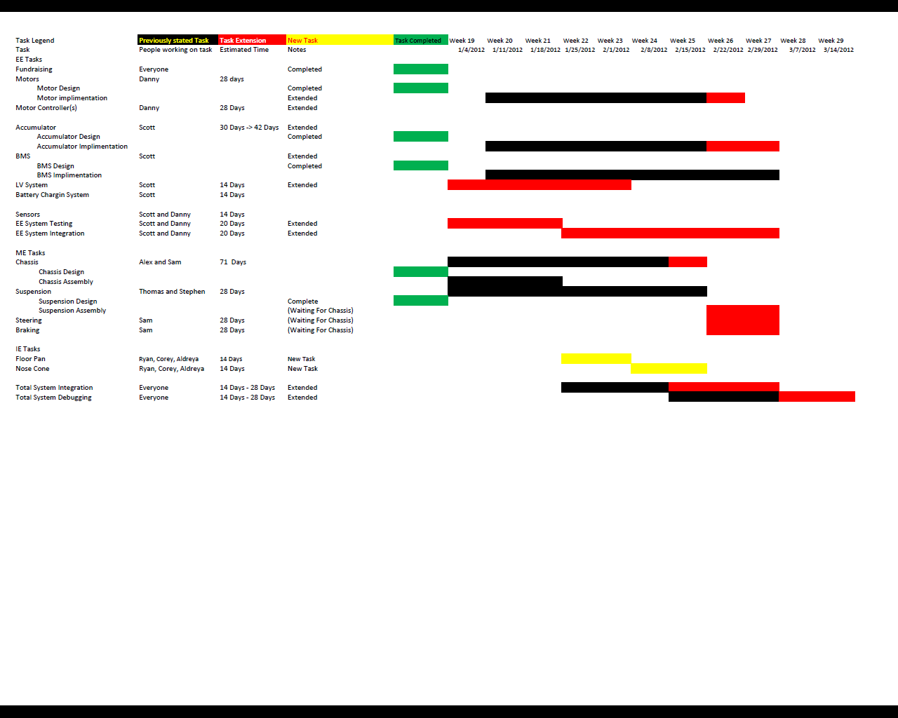

# Budget Estimate

## Budget

Our current budget is a total of $2,196.92 which does not include a promised corporate donation of $2,000

|  |  |
| --- | --- |
| Remaining Funds in Accounts | Outstanding donations |
| $2,197 | $2,000 |

These funds should be sufficient to complete at least a baseline model of a qualifying vehicle.

## Purchase History

* A $486.22 order of tubing for chassis construction was processed and received.
* A $316.24 order of items for electrical systems, such as connectors and cell boards, was processed

## Present Purchases

### Electrical

Due to an error with the previously established supplier of our Lithium-polymer batteries, we have had to return to the market for another supplier. It appears likely that we will change our battery option to a lead acid battery and process an order as soon as a supplier is decided upon. These batteries also have the advantage of having a longer life expectancy and energy capacity, which means that they can still be valuable to next year’s team and they will fare well in endurance races ,which has been crucial to obtaining our competitive edge in former competitions.

The necessity for additional purchases has been realized through our current inspection. These are documented in the inspection section of this report.

### Mechanical

The majority of purchases for mechanical components have been processed. A few additional items are presented in the inspection section of this report.

### Industrial

The fabrication of a composite outer body and floor-pan is currently being planned. The design and bill of materials will be complete within the next two weeks and, after any necessary purchases are made, the endeavor will be undertaken shortly after.

# Conclusion

As can be seen in the sections above, the vehicle is comprised of many systems and subsystems that vary in complexity. Although when designing these systems, it is often easy to become so focused on the system itself that the method of integrating it into the vehicle is often neglected, it is a crucial consideration since these individual systems must eventually be integrated to produce a working vehicle.

As a result of continuously meeting and communicating with each other, the members came to realize this early on, which avoided many problems that would have otherwise arisen, possibly resulting in major design changes. There are, of course, many systems where the inter-relationship is very apparent, but, in those that are not, communication was essential, along with the design approach mentioned previously mentioned in this paper. Even though the design method for each system is different, the initial approach for each consisted of a deep consideration for the system’s goals and the various ways to create the design in a practical manner.

The team members have done this for this project and are finalizing the designs and are currently working on the fabrication of completed designs, such as the chassis. The team members have also tried to work well in an interdisciplinary setting. Though it has been challenging thus far, much progress has been made.

# References

1. "2012 Formula Hybrid™ Rules." Thayer School of Engineering at Dartmouth, 25 Aug. 2011. Web. 19 Oct. 2011. <http://formula-hybrid.org/pdf/Formula-Hybrid-2012-Rules.pdf>.
2. A- ISOMETER IR155-2 Fault Detector

See attachment in appendices called GFD

1. A- ISOMETER IR155-2 Fault Detector

See attachment in appendices called GFD

1. BMS Orion
2. BMS Elithion.com
3. Cloud electronic.com
4. http://www.cloudelectric.com/product_p/bc-hwc4-72v-fslash-30a.htm
5. http://elithion.com/products.php
6. "FAMU-FSU COLLEGE OF ENGINEERING FSAE SENIOR DESIGN." *FAMU-FSU College of Engineering :: Welcome*. Web. 30 Nov. 2011. <http://eng.fsu.edu/me/senior_design/2003/team1/>.
7. "HowStuffWorks "How Car Steering Works"" *HowStuffWorks "Auto"* Web. 30 Nov. 2011. <http://auto.howstuffworks.com/steering2.htm>.
8. J.A. Marin, J.E. Armstrong, and J.L. Kays, “Elements of an Optimal Capstone Design Experience,” Journal of Engineering Education, January 1999, pp. 19-22.
9. Li-po Batteries

http://www.hobbyking.com/hobbyking/store/__18560__Turnigy_5000mAh_1S_20C_Lipoly_Single_Cell_.html

1. LiFePO4 Batteries
2. http://www.orionbms.com/
3. Milliken, William F., and Douglas L. Milliken. *Race Car Vehicle Dynamics*. Warrendale, PA, U.S.A.: SAE International, 1995. Print.
4. *Performance Brakes - Brake Pads, Brake Rotors and Brake Kits*. Web. 30 Nov. 2011. <http://www.brakeworld.com/>.
5. Stone, Richard, and Jeffrey K. Ball. *Automotive Engineering Fundamentals*. Warrendale, PA: SAE International, 2004. Print.
6. FSAEOnline.com. Web. 29 Jan. 2012. <http://www.fsaeonline.com/>.
7. "Testing Brakes with StopTech." Zeckhausen Racing. Web. 29 Jan. 2012. <http://www.zeckhausen.com/Testing_Brakes.htm>.
8. Welcome to Wilwood Engineering - Specialty OEM Applications, Racing, and Street Performance Disc Brakes. Web. 29 Jan. 2012. <http://www.wilwood.com/>.

# Test Plan Documents

**Scheduled Test Reporting Form**

Test Item: Batteries

Tester Name: Scott Hill Tester ID No: TBD

Test Date: TBD Test No: 1

Test Time: TBD Test Type: Test

Test Location: TBD Test Result: TBD

Test Objective:

The objective is to ensure that each battery is providing the proper voltage and that when connected to a resistive load that the current output is what it should be

Test Description/Requirements:

First the voltage of each battery will be tested to make sure that it is 12V. Once the voltage has been verified each battery will be connected to a resistive load to make sure that a proper current reading is being taken. The current will be read by a fluke.

Anticipated Results:

Each battery should register a voltage that is within 0.5V of the 12V nominal voltage. Once the voltages have been verified the resistor will be connected to each battery individually and the current will be measured and verified by Ohm’s law.

Requirement for Success:

Each battery should register a voltage that is within 0.5V of the 12V nominal voltage. Once the voltages have been verified the resistor will be connected to each battery individually and the current will be measured and verified by Ohm’s law.

Actual Results:

TBD

Reason for Failure:

N/A

Recommended Fix:

N/A

Other Comments:

**Scheduled Test Reporting Form**

Test Item: BMS Testing (Test will not be performed if lead acid batteries are used)

Tester Name: Scott Hill Tester ID No: TBD

Test Date: TBD Test No: 2

Test Time: TBD Test Type: Test

Test Location: TBD Test Result: TBD

Test Objective: This test will determine if the BMS is monitoring the temperature and voltage of the batteries properly

Test Description/Requirements: The test will consist of the following components:

1. BMS Controller
2. BMS Cell Boards
3. Lipo Batteries

A voltmeter will be used across the individual batteries and the voltages will be compared with the voltages being read by the cell boards of the BMS by connecting the BMS master to a laptop computer.

Anticipated Results:

The voltages that the BMS master and the voltmeter are reading should match up.

Requirement for Success:

The voltages that the BMS master and the voltmeter are reading should be within a 10% margin of error

Actual Results:

TBD

Reason for Failure:

N/A

Recommended Fix:

N/A

Other Comments:

**Scheduled Test Reporting Form**

Test Item: Low Voltage Circuit Component Testing

Tester Name: Scott Hill and Danny Covyau Tester ID No: TBD

Test Date: TBD Test No: 3

Test Time: TBD Test Type: Test

Test Location: TBD Test Result: TBD

Test Objective: This test will confirm that the low voltage components such as but not limited to the:

1. Energized strobe light
2. Dashboard Sensors
3. Ground fault detector connections

Test Description/Requirements:

The test will be used to confirm that the correct voltages are being read at the input of all components. Components such as the strobe light will be checked to make sure that they are lighting up properly

Anticipated Results:

The correct voltages should be read off of the input of all components and the strobe light should light up properly. The gauges from the dash should also read proper values that correspond to different voltages.

Requirement for Success:

The strobe light must be light up in a way that bystanders know that the vehicle is energized. The voltages on the inputs of the low voltage components must read within a 10% tolerance.

Actual Results:

TBD

Reason for Failure:

N/A

Recommended Fix:

N/A

Other Comments:

**Scheduled Test Reporting Form**

Test Item: Battery Integration Testing

Tester Name: Scott Hill and Danny Covyeau Tester ID No: TBD

Test Date: TBD Test No: 4

Test Time: TBD Test Type: Test

Test Location: TBD Test Result: TBD

Test Objective:

This test will involve the batteries, the motor controller and the motor. The objective of this test is to connect the batteries to the motor controller and confirm that the batteries are properly powering the motor

Test Description/Requirements:

The batteries will be connected in such a way that the desired voltage is achieved. Then the batteries will be connected to the motor controller which will already be connected the motor. The motor controller will be activated using the potbox as a means of a gas pedal and the rpm of the motor will be measured.

Anticipated Results:

When the potbox is pushed down the motor controller should let increasing voltages through to the motor thus letting the vehicle accelerate as the pedal is pushed down.

Requirement for Success:

The motor should increase in rpm as the pedal on the potbox is pushed down. There should be no major fluctuations in the rpm of the motor that would damage the vehicle.

Actual Results:

TBD

Reason for Failure:

N/A

Recommended Fix:

N/A

Other Comments:

**Scheduled Test Reporting Form**

Test Item: Ground Fault Detection Test

Tester Name: Scott Hill Tester ID No: TBD

Test Date: TBD Test No: 5

Test Time: TBD Test Type: Test

Test Location: TBD Test Result: TBD

Test Objective:

This test will make sure that if there is a fault between the HV circuit and LV circuit that a relay will be tripped and shut off the vehicle.

Test Description/Requirements:

A connection between the HV and LV circuits will be made with only 12V connected to the HV circuit for safety reasons. This connection will have a resistance that is about 10% under the limit for the circuit needing to be tripped.

Anticipated Results:

The GFD circuit will be tripped and the vehicle will need to be reset by someone outside of the driver’s seat.

Requirement for Success:

The GFD circuit must be tripped in order for the team to pass safety inspection at the competition.

Actual Results:

TBD

Reason for Failure:

N/A

Recommended Fix:

N/A

Other Comments:

**Scheduled Test Reporting Form**

Test Item: Potbox – Component Testing: Normal Operation

Tester Name: Danny Covyeau Tester ID No: TBD

Test Date: TBD Test No: 1

Test Time: TBD Test Type: Test

Test Location: TBD Test Result: TBD

Test Objective:

The objective of this test is to verify the proper operation of the throttle potentiometer (potbox).

Test Description/Requirements:

The throttle will be tested to make sure that when hooked up to a five volt power supply that it delivers a range of voltage output between zero and five volts. The following equipment will be needed perform this test:

1. a power supply
2. Potbox
3. Voltmeter

Anticipated Results:

The potbox will act as a simple voltage divider and deliver voltage levels that range from zero to five volts.

Requirement for Success:

The potbox must deliver a range of voltages between zero and five volts.

Actual Results:

TBD

Reason for Failure:

N/A

Recommended Fix:

N/A

Other Comments:

**Scheduled Test Reporting Form**

Test Item: Throttle Isolation Circuit

Tester Name: Danny Covyeau Tester ID No: TBD

Test Date: TBD Test No: 1

Test Time: TBD Test Type: Test

Test Location: TBD Test Result: TBD

Test Objective:

This test is to ensure that the throttle isolation circuit works correctly (i.e. that the LV and HV grounds have a minimum resistance of 40,000 ohms between them and that the output voltage of the circuit corresponds linearly with the input voltage of the circuit).

Test Description/Requirements:

The optoisolator circuit will be built. A five volt source will be placed across the potbox (or a five thousand ohm potentiometer in the case that the throttle is not available). The potentiometer will be actuated randomly and the resulting input and output voltages will be measured with a voltmeter.

Anticipated Results:

The input and output voltage of the throttle will be varied from zero to five volts linearly.

Requirement for Success:

The input and output voltage of the throttle must vary linearly with five volts at the input corresponding to four or more volts at the output.

Actual Results:

N/A

Reason for Failure:

N/A

Recommended Fix:

N/A

Other Comments

**Scheduled Test Reporting Form**

Test Item: Electric Motor Controller – Component Testing: Normal Operation

Tester Name: Danny Covyeau and Scott Hill Tester ID No: TBD

Test Date: TBD Test No: 1

Test Time: TBD Test Type: Test

Test Location: TBD Test Result: TBD

Test Objective:

The objective of this test is to verify that the electric motor controller works properly. The forward and reverse functions of the motor will be tested.

Test Description/Requirements:

The electric motor controller will be tested to verify that it operates the motor in the forward and reverse directions. The following equipment will be needed perform this test:

1. A power supply (preferably 72 volts)
2. Kelly Motor Controller – KD72501
3. Electric motor – Agni 95R
4. Peripheral electronics connected to the controller

Anticipated Results:

The motor controller will be able to accelerate the electric motor in both the forward and reverse directions.

Requirement for Success:

The motor controller must be able to accelerate the electric motor in both directions.

Actual Results:

TBD

Reason for Failure:

N/A

Recommended Fix:

N/A

Other Comments:

**Scheduled Test Reporting Form**

Test Item: Chassis

Tester Name: George Nimick Tester ID No:

Test Date: TBD Test No: Chassis_1

Test Time: TBD Test Type: Test

Test Location: CoE Computer Lab Test Result: TBD

Test Objective:

The objective of this test is to verify that all components have an adequate amount of space and that there is proper clearance between parts and chassis frame members.

Test Description/Requirements:

In order to perform this test, a 3-Dimensional Computer Aided Design program is necessary. This program will be used to create a model of the chassis as well as models of the components that will fit within the parameters of the chassis.

Anticipated Results:

It is anticipated that all components will fit properly as this is a inherent part of the design and can be tested and adjusted prior to building the actual protype. Therefore, when building the actual prototype, everything is expected to fit.

Requirement for Success:

The requirement for success is for all components to be able to fit and have adequate space to properly function in there tentative place within the chassis.

Actual Results:

Based on the model, everything appears to fit properly. The fitment of actual components will fully determine the results.

Reason for Failure:

N/A

Recommended Fix:

N/A

Other Comments:

**Scheduled Test Reporting Form**

Test Item: Chassis

Tester Name: George Nimick Tester ID No:

Test Date: TBD Test No: Chassis_2

Test Time: TBD Test Type: Test

Test Location: CoE Computer Lab Test Result: TBD

Test Objective:

The objective of this test is to verify that the chassis configuration and triangulation conforms to the rules.

Test Description/Requirements:

The SAE Formula Hybrid competition has compiled a set of rules to which the chassis must abide by. Failure to do so will result in exclusion from the participation of any of the events. There are specific requirements regarding dimensions, triangulations and characteristic members that the chassis must contain.

Anticipated Results:

It is anticipated that the chassis will pass this test. The rules have been reviewed several times and there has been a significant amount of communication between the designer and the mechanical scrutineers regarding proper practices, clarification of the rules and an actual review of the triangulation of the frame members.

Requirement for Success:

Must be able to pass technical inspection

Actual Results:

TBD

Reason for Failure:

N/A

Recommended Fix:

N/A

Other Comments:

**Scheduled Test Reporting Form**

Test Item: Chassis

Tester Name: George Nimick Tester ID No:

Test Date: TBD Test No: Chassis_3

Test Time: TBD Test Type: Test

Test Location: CoE Computer Lab Test Result: TBD

Test Objective:

The objective of this task to verify the structural integrity of the vehicle and to use the opportunity to allow for a set up that distributes stresses and loads as evenly as possible, and to minimize weight, if possible.

Test Description/Requirements:

The chassis will be created or transferred to a finite element analysis program, such as ALGOR, COMSOL, or SolidWorks Xpress Simulation. The chassis will then be constrained and loaded depending upon the scenario that will be analyzed. The chassis will be analyzed under various loads simulating crashed and/or loads from suspension components.

Anticipated Results:

The chassis should be of adequate strength to endure the loads that it should receive under normal operating conditions. Since accidents can vary in severity, the key element that will be analyzed is whether or not it will be able to protect the driver.

Requirement for Success:

The chassis should be able to protect the driver and the components within the vehicle and there should be no deformation of the frame members while using it under the specified conditions that it was designed for; specifically, these conditions include driving and maneuvering on smooth pavement, with banked and unbanked turns, and through an autocross course.

Actual Results:

TBD

Reason for Failure:

N/A

Recommended Fix:

N/A

**Scheduled Test Reporting Form**

Test Item: Suspension components

Tester Name: Stephen Kempinski Tester ID No:

Test Date: Mid/Late February Test No: Susp_1

Test Time: In daylight Test Type: Measurement and accuracy

Test Location: COE Machine Shop Test Result: TBD

Test Objective:

The objective of this test is to verify that all the suspension components meet competition rules/specs.

Test Description/Requirements:

With the construction of the suspension near completion, final accurate measurements of the suspension components will be measured and compared to the rules and team design to ensure accuracy. The wheel base, track width, jounce, and rebound of the suspension all need to take on a final measurement before the final welding of the attaching brackets is completed so that any necessary changes can take place before it is too late.

Anticipated Results:

All of the suspension components should be within specs according to the 2012 Formula-Hybrid Competition rules which were followed in the design.

Requirement for Success:

The suspension components will meet rules and design specs for optimal handling.

Actual Results:

TBD

Reason for Failure:

N/A

Recommended Fix:

N/A

Other Comments:

**Scheduled Test Reporting Form**

Test Item: Suspension components

Tester Name: Stephen Kempinski Tester ID No:

Test Date: Mid/Late March Test No: Susp_2

Test Time: In daylight Test Type: suspension alignment

Test Location: COE Machine Shop Test Result: TBD

Test Objective:

The objective of this test is to measure and set suspension characteristics of toe, camber, and caster .

Test Description/Requirements:

With the construction of the suspension completed, the angles for toe, camber, and caster need to be measured and set to the desired angles. This will either require the vehicle to go to an automotive shop where an alignment can be done with computer that takes measurements from sensors mounted to each individual wheel, or the team can take various carful measurements and make adjustments accordingly. The team can then test the car and see how changes affect the behavior on acceleration, braking, and cornering.

Anticipated Results:

The team will determine the best set up for autocross with a few trial and error tests

Requirement for Success:

The suspension components will be fine tuned to achieve optimal handling.

Actual Results:

TBD

Reason for Failure:

N/A

Recommended Fix:

N/A

Other Comments:

**Scheduled Test Reporting Form**

Test Item: Brake assembly

Tester Name: Sam Risberg Tester ID No:

Test Date: 2012 Test No: 1

Test Time: Test Type: Test and check with rules

Test Location: College of Engineering Lab Test Result: TBD

Test Objective:

The objective is to test the braking system of the formula hybrid car for functionality, safety and that everything follows the rules of the competition.

Test Description/Requirements:

The test will include the pads, rotors, calipers, and brake lines. First to test the brake pads and rotors we will put the car under heavy acceleration and decelerate the car as quickly as possible. Doing this multiple times will put the car into the desired heat cycles that the competition will put the pads and rotors through. Making sure there is no grooves in the rotors or pads and that the heat is evenly distributed. This will ensure proper and uniform braking. For the calipers there are two things needed to check. First is that the caliper doesn’t leak brake fluid. Next is that that caliper has proper clamping force. A normal braking test will ensure both of these after inspection. The brake lines hold the brake fluid and proper function would mean that there is no leaks in the lines. An inspection of the floor where the car has been sitting over night and every connecting joint of the brake lines will show any failure.

Anticipated Results:

We expect all pads, rotors, calipers and brake lines to be problem free, considering they are very simple parts and should not degrade over time.

Requirement for Success:

Follow all rules of the competition

Actual Results:

TBD

Reason for Failure:

TBD

Recommended Fix:

TBD

Other Comments:

If there are any problems with the brakes replacement and/or repair should come quickly and easily.

**Scheduled Test Reporting Form**

Test Item: Steering Assembly

Tester Name: Tomas Bacci Tester ID No:

Test Date: TBD Test No: Steer_1

Test Time: TBD Test Type: Rule Verification

Test Location: College of Engineering Lab Test Result:

Test Objective:

The objective of this test is to verify that the steering assembly on the vehicle complies with the competition rules while providing the desired turning characteristics.

Test Description/Requirements:

The test will require for the all steering components – tie rods, rack, column, wheel, stops and rod ends- to be attached to the chassis in its end form. The free play in the wheel must be measured to be 7 degrees or less when mildly turned. When the wheel pivots the rack from lock-to-lock position, the wheels and hubs must not come in contact with the chassis assembly. The steering link must also be verified to have proper clearance to allow for any possible suspension travel. Overall rigidity of system will also be verified, and the toe angles at the wheel will be measured and compared to verify a small amount of Ackermann geometry. Quick disconnect of the wheel will be tested for basic functionality.

Anticipated Results:

The steering assembly should properly function and meet competition requirements as well as performance requirements

Requirement for Success:

No competition rule can be ignored.

Actual Results:

N/A

Reason for Failure:

N/A

Recommended Fix:

N/A

# Appendices (optional)

## Appendix A – Chassis





## Appendix B – Braking

**The kinetic energy equation**



**The kinetic energy produced from a 70mph stop**



**Time that a 70mph stop will take**



**Energy the stop will produce**



**Force required for this braking situation**



## Appendix C – Steering

14" Mini Dune Buggy rack and pinion steering unit, 1.5’ lock-lock, 12:1 gear ratio

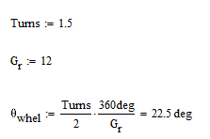

Sample Tire Performance curve for a racing tire. Peak of cornering force occurs at higher angles for stronger loads.

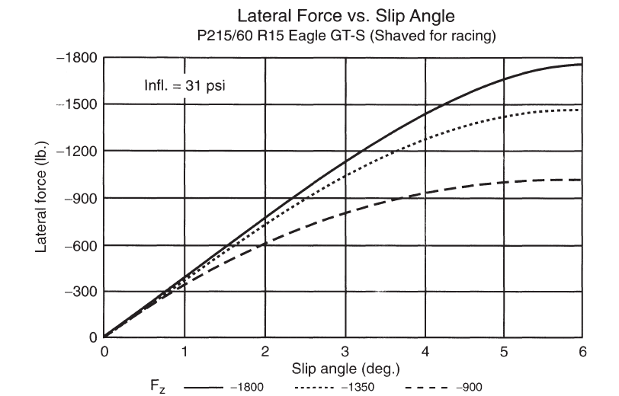

## Appendix D - Electrical System Figures

Figure A. Lipo Battery Configuration with Fusing

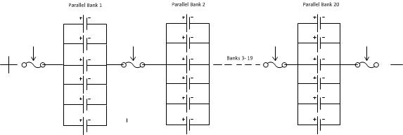

Figure B. Mathematical Model for Battery Design

